SECTION 3
EROSION CONTROL – SUMMARY

Revised as of 12/06/2018

Please find an attached sample of an erosion control plan. The example states that the contractor will comply with the Storm Water Pollution Prevention Plan (SWPPP) and permit requirements. If there is no FDEP or EPA NPDES permit or SWPPP, then modify the letter providing the information required by specification 104.
Read the Special Provisions of the contract to see if there are any modifications to Section 104 of the Specifications. Your erosion control plan may have to be modified to comply with the Special Provisions. Locate and draw erosion and sediment control devices and temporary and permanent stabilization measures on the MOT plan sheets. If the set of contract plans does not include MOT plan sheets, use the plan profile sheets.

Specification Section 104-5 requires the erosion control plan to be submitted in the format provided by the Department which is being identified in this Section. The erosion control plan shall describe, but not be limited to, the following items or activities:

(1) For each phase of construction operations or activities, supply the following information:
A. Locations and types of all erosion control devices identified in the letter and drawn on MOT or plan profile sheets.
B. Locations and types of all temporary and permanent stabilization measures. identified in the letter and drawn on MOT or plan profile sheets.
C. Estimated time erosion control devices will be in operation.
D. Monitoring schedules for maintenance of erosion control devices.
E. Methods of maintaining erosion control devices.

(2) Name and telephone number of the person responsible for monitoring and maintaining the erosion control devices.

You will need to base the schedule on an analysis of the project conditions.

The erosion control plan provided by the designer is preliminary and does not reflect the contractor’s sequence of construction or his chosen means and methods. Your erosion control plan must include a detailed “construction sequence and phasing plan” reflecting your specific means and methods for constructing the project. In the erosion control plan describe all soil disturbing activities, durations, and related control and stabilization measures.

The erosion control plan should include the sequence of clearing and grubbing, earthwork operations, construction of permanent erosion control features, and the proposed uses of temporary erosion control features and stabilization. This plan should list the station numbers from the contract drawings to identify where the erosion control features will be used in the various operations of the contractor. If for example, the silt fence is required along both sides of the entire project, then the stations will be from the beginning of the project to the end. However, if the silt fence is only required at certain areas of the project, say around box culvert extensions, then the plan will list each area for the timeframe the contractor estimates it will take to complete the work in that area. The plan should show the temporary measures taken prior to the operation, maintaining them during the operation, then placement of the final erosion control features.

Public Notice of Pollution Act Chapters 403.076 through 403.078 F.S.
In accordance with the Public Notice of Pollution Act of 2017, the contractor and each of their subcontractors (collectively referred to as “Contractor”) shall be required to provide notice of a reportable pollution release, as defined in Chapter 403.077(1), to the following parties: the Florida Department of Environmental Protection at http://dep.state.fl.us/pollutionnotice/, the Division of Emergency Management State Watch Office (800-320-0519 or 850-413-9911) and the FDOT Construction Project Engineer. Notice is required to occur within 24 hours of the Contractor’s discovery of the reportable pollution release. This law is in addition to the reporting requirements from the FDEP Construction Generic Permit (CGP) for projects disturbing more than an acre for coverage under the National Pollutant Discharge Elimination System (NPDES) implemented in 2015.

FDEP Pollution Notice Form https://floridadep.gov/pollutionnotice
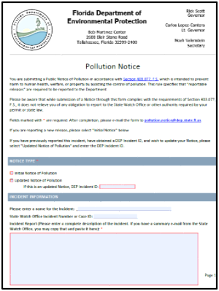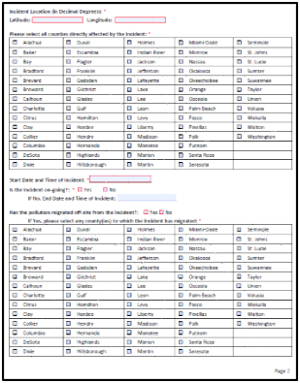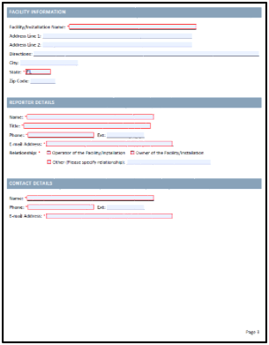

Also at the Preconstruction Conference Meeting, provide the following:

1. Submit a copy of the submitted Notice of Intent (application and acknowledgement letter) for the FDEP Generic Permit for Stormwater Discharge from Large and Small Construction Activities.

2. If not included in the FDEP NPDES permit coverage, submit a copy of the Notice of Intent (application and acknowledgement letter) for the FDEP Generic Permit for the Discharge of Produced Ground Water from any Non-Contaminated Site Activity.

3. Submit a copy of the St. Johns River Water Management District Notice of Intent to use Noticed General Permit for Short Term Construction Dewatering.

4. Submit a copy of the FDEP Stormwater Erosion and Sediment Control Inspector Training Certification for the person responsible of erosion control on the project.

5. Submit Certification Form 650-040-07 signed with valid digital signature and must be signed by a Duly Authorized Representative. Form will be completed by the prime contractor and every environmental subcontractor implementing any portion of the SWPPP, such as the grassing subcontractor and the subcontractor installing the erosion control items. This is required for compliance with the FDEP and EPA NPDES permits. Submit the forms to the Resident Engineer at the Preconstruction Conference, and if no subcontract signed by that time, the form must be submitted to the Resident Engineer at least 7 days prior to the subcontractor beginning work on the project.

Print a copy of Form 650-040-07 Contractor Certification/NPDES General Permit for Storm Water Discharges

6. For ALL non-company officers for Prime and Sub Contractors signing any or all required items of the FDEP NPDES Construction Generic Permit (Notice of Intent and Notice of Termination), SWPPP Inspection Reports and Certification Form 650-040-07 must submit a Duly Authorized Representative (DAR) notice to FDEP (NPDES-stormwater@dep.state.fl.us) in accordance with the FDEP NPDES Permit. This process is required to repeat every time roles are changed for the life of the project. SWPPP Inspection Reports and Certification Forms require valid digital signature.

TIGER CONTRACTING COMPANY
2435 Willow Lane Jacksonville, FL 35548
(904) 678-9642 FAX (904) 678-9645

October 11, 2018

Mr. Do Right, PE
Resident Engineer
Department of Transportation

1109 South Marion Ave
Lake City, FL 32025

Subject: SECTION 104-5 EROSION CONTROL PLAN
SR-16, From I-925 to Cotton Picker Road
FINPROJ No.: 213958-1-52-01
FAP No.: D-911-4(5)
Contract No.: T3456
County: Columbia

Attention: Mr. Do Right

The following Erosion Control Plan is submitted as required by Standard Specification and Special Provision 104-5 and is consistent with / modifies the Stormwater Pollution Prevention Plan (SWPPP) provided in the contract package. (Contractor has the option of preparing their own SWPPP.)

The sequence of work will be as follows: (clearing and grubbing, earthwork operations, temporary or permanent erosion control feature installations or as addressed in the Work Progress Schedule Chart)

The Environmental Permits that apply to this project are:
Florida Department of Environmental Protection (FDEP) – FLR20CK93-001
St. Johns Water Management District - 87672-1
US Army Corps of Engineers - SAJ-2013-01947(IJ-PU)
United States Coast Guard – 16591/3850

Prior to the commencement of any work, all temporary erosion control features, and where practical, permanent erosion control features, will be installed to effectively control erosion and prevent off-site discharge, and to comply with all applicable environmental permits. Stabilization of erodible areas will commence within the time limit established by permit or the SWPPP using one of the stabilization methods outlined in the SWPPP and shown on the submitted MOT or plan profile sheets.

Temporary erosion control features will be installed at the following locations:

Location Type Estimated time in use Work Sequence
1)Sta. __ to Sta. __ Device ____ # of days ______ Sequence __________
2)Sta. __ to Sta. __ Device ____ # of days ______ Sequence __________
3)Station ___ Device ____ # of days ______ Sequence __________
4)Station ___ Device ____ # of days ______ Sequence __________
5)……….
6)……….
7)……….
Etc. to the n^{th} location

(List each station of temporary erosion control features or list each structure number that may apply – BUT – the estimated length of time in use and the work sequence still need to be provided for each temporary erosion control feature. Device is the type of erosion control that is to be used like hay bales, silt fence, turbidity barrier, etc)

These temporary erosion control feature will be used to protect the following water bodies or wetland areas during construction:

Waterway –

Wetland -

The monitoring schedule for maintenance of the erosion control features:
The erosion control features on the project will be monitored daily to determine if maintenance or modification of erosion control features is needed.

Maintenance of the erosion control features:
The erosion control features will be maintained within 3 days of the inspection or within the timeframe identified in the SWPPP.

Containment and removal of pollutants, solid wastes, and hazardous wastes:
Any waste oil will be collected and returned to oil storage tanks for proper disposal. Other pollutants and hazardous wastes will be properly contained and disposed. Solid waste will be disposed at locations/ facilities.

For projects that involve culvert/bridge demolition of components over water, describe the containment and collection measures that will be implemented to prevent solid and liquid debris from being discharged into the water.
In addition to the FDEP Construction Generic Permit reportable requirements, our company will submit all unauthorized releases or spills, as defined in Chapter 403.077(1), to the Public Pollution Notice in accordance with Chapter 403.076 through 403.078 F.S., the State Watch Office (800-3200519 or 850-413-9911) and the FDOT Construction Project Engineer within 24 hours of the discovery.

The person responsible for erosion control on the project is _______________(name), their phone number with area code is __________________ and their inspector number is ____________. A copy of their FDEP Stormwater Erosion and Sediment Control Inspector Training Certification is attached.

Embankment is intended to be obtained from a commercial source / local sources.

Erosion control in non-commercial off-site construction areas will be controlled as needed by the following methods:

Borrow area – Options - Maintain natural buffer adjacent to haul road
Dust control

Grassing
Other (specify)
No borrow material will be used on this project.

Storage Area – Options – Maintain natural buffer adjacent to storage area
Grassing
Other (specify)

See additional requirements attached:

A copy of our FDEP CGP NPDES Permit application and acknowledgement letter.

Completed Form 650-040-07 for our company and every environmental sub-contractor working on this project signed with signature authority.

A copy of the email to FDEP Notices Center and the Duly Authorized Representative Delegation Letter. We understand this requirement must be kept updated till the FDEP CGP NPDES Notice of Termination has been filed.

Copies of each email to the ACOE and SJRWMD regarding the required Construction Commencement Notice in accordance with the permit conditions are attached.

A copy of the email to USFWS stating we will be using their plan for the Eastern Indigo Standard Protection Measures is attached. We are planning on having the required annual training on _______________ (DATE) and will invite the FDOT construction staff to attend.

Sincerely,

George T. Wise
President

CTJ/bb

