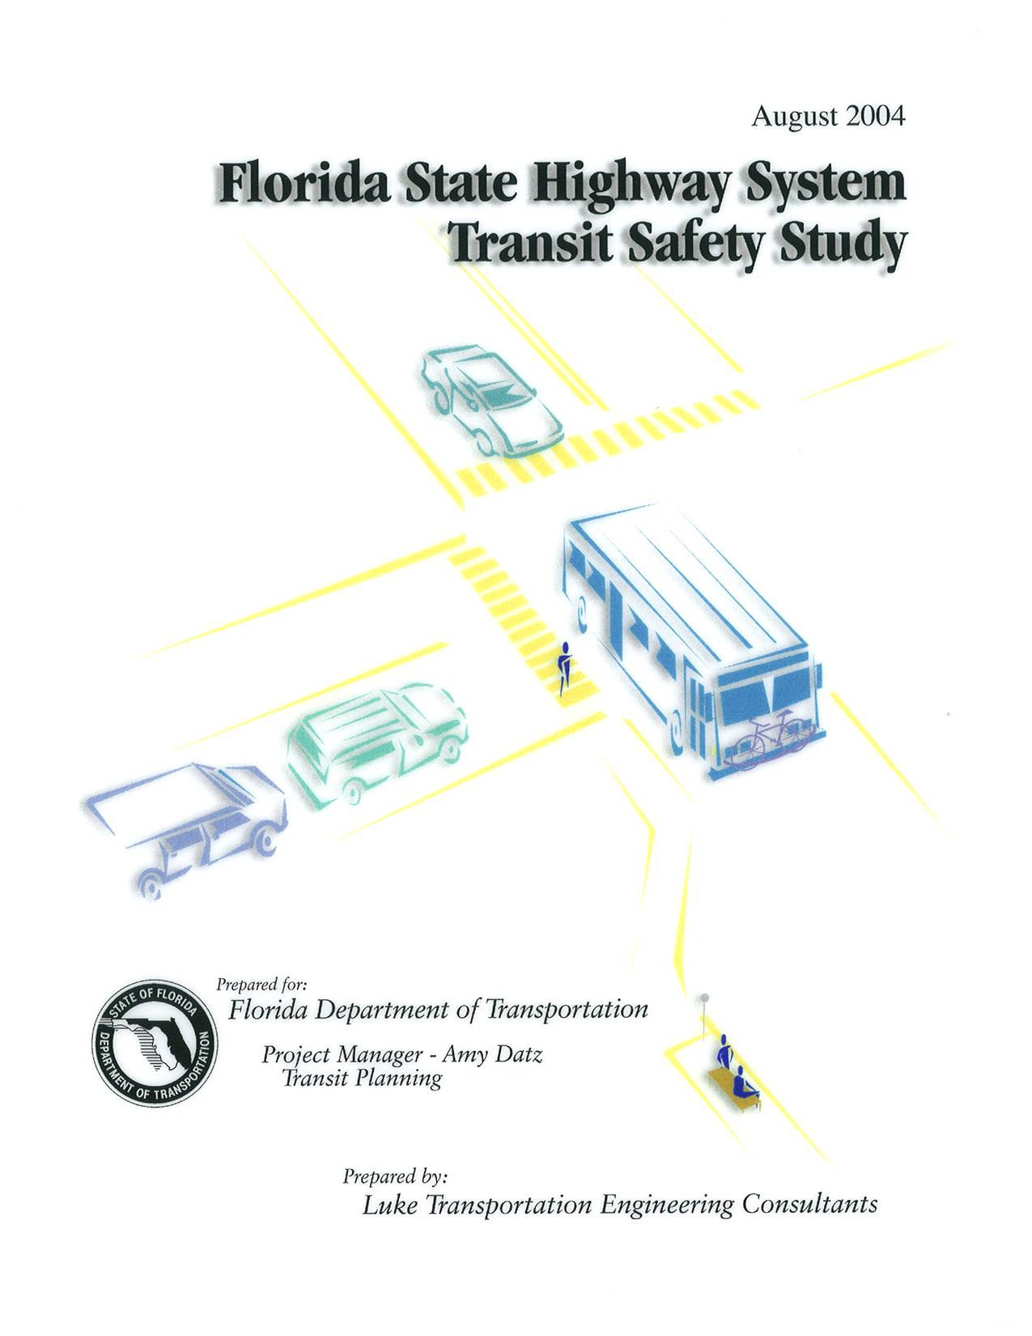
FLORIDA STATE HIGHWAY SYSTEM
TRANSIT SAFETY STUDY

prepare for:

florida department of transportation
605 Suwannee St. MS 26
Haydon Burns Building
Tallahassee, FL 32399-0450

PREPARED BY:

LUKE TRANSPORTATION ENGINEERING CONSULTANTS, INC

29EAST PINE STREET

ORLANDO, FL 32801

August 2004

TABLE OF CONTENTS
Page

1.0 Introduction 1

1.1 Study Purpose 1

1.2 Study Approach 2

2.0 ACCIDENT data ANALYSIS 4

2.1 Methodology 4

2.2 System Mapping 4

2.3 Accident Data Parameters 8

2.4 Identification of High Accident Locations 11

2.5 Analysis of Accident Data 13

3.0 TRANSIT SYSTEM ACCIDENT DATA 25

3.1 Purpose And Approach 25

3.2 Transit Agency Surveys 25

3.2.1 Methodology 25

3.2.2 Develop Survey Instrument 26

3.2.3 List of Agencies 27

3.2.4 Interview Approach 28

3.2.5 Interview Survey Results 28

3.2.6 Summary of Interview Survey Data 30

3.2.7 Trends 32

3.2.8 Summary 34

3.3 Analysis of National Transit Database Safety Data 35

3.3.1 NTD Data Collection and Reduction 35

3.3.2 All Florida Transit Systems - MB Incidents, Fatalities and Injuries 38

3.3.3 All Florida Transit Systems – Accident by Type 43

3.3.4 Comparative Analysis-Accident Rates for a Largest

Transit System (2001) 47

3.3.5 Summary 50

4.0 conclusions and recommendations 51
Exhibits
Page
- Florida’s Transit Agencies 6
- Sample of Accident Data 9
- Number of Crashes by Location 15
- Distribution of All Crashes 16
- Driver / Vehicle At Fault 17
- Location Description 18
- County of Locations 19
- General Point of Impact 20
- Proportion of Crashes Where Autos Struck Rear Area of Buses 22
- High Accident Locations by Category 23
- Results of Survey Data 30
- MB Incidents 37
- MB Incidents Per Million Vehicle Miles 38
- MB Incidents Per Million Passenger Miles 38
- MB Fatalities 39
- MB Fatalities Per Million Vehicle Miles 39
- MB Fatalities Per Million Passenger Miles 40
- MB Injuries 40
- MB Injuries Per Million Vehicle Miles 41
- MB Injuries Per Million Passenger Miles 41
- MB Accidents by Type 43
- Collisions With Other Vehicles 44
- Inside Vehicle 44
- Boarding / Alighting Vehicle 45
- In Stations / Bus Stops 45
- Collisions With Other Vehicles (2001) 47
- Inside Vehicle (2001) 47
- Boarding / Alighting Vehicle (2001) 48
- In Stations / Bus Stops (2001) 48
APPENDICES

appendix a – State Highway System with Transit Routes Maps Statewide
APPENDIX B – Sample FDOT Crash Report
APPENDIX C – CAR Manual – Crash Report Description
APPENDIX D – Explanation of ACCESS Database
APPENDIX E – Categories 1 – 4 Spreadsheets
APPENDIX F – Categories 2 – 4 Collision Diagrams
APPENDIX G – Crash Locations Chart
APPENDIX H – High-Accident Location Area Maps
APPENDIX I – Sample Survey and Transit Agency List
APPENDIX J – Completed Surveys

1.0 INTRODUCTION

STUDY PURPOSE
In developing the scope of work for this project, the overall goal identified by the Florida Department of Transportation (FDOT) was to determine design considerations for the State and Federal Highway System that would eliminate or reduce accidents at transit stops, routes, and stations, involving public transit vehicles. Ancillary goals included increased Levels of Service (LOS) for traffic flow on the State (and Federal) Highway System (SHS) adjacent to the transit stop or station, or increased efficiency and safety of pedestrian and bicycle movements and access for these locations.
As the scope of work was developed, it was agreed with the FDOT that the initial phase of the project would include the assembly of accident (crash) data collection and a research phase to identify where accidents have historically occurred that impacted transit vehicles or passengers along existing transit routes, stops and stations on the SHS within Florida. The central goal of the project was to identify the effects of highway design on the safety of transit facilities. The study involved the assembly and review of operational and safety/accident records where transit is operational and where design changes would improve the traveling safety of the vehicles and passengers. This data evaluation identified the high accident locations along existing transit routes, stops, and stations on the SHS. The study was limited to the analysis of the fixed bus route components of transit systems. Based on the evaluation of the data, accident trends were identified and recommended solutions were developed.
After completion of this study phase of the overall project, a second phase would be initiated to implement the recommendations or follow through with the findings of the study phase.
This report summarizes the initial phase associated with the assembly and research of accident data that would be utilized in meeting the overall FDOT goals.

1.2 STUDY APPROACH
The State of Florida includes a large number of transit systems with hundreds of bus stops and stations located on state and federal highways. This study required the assembly and analysis of historical accident data, statewide. As part of the scope development for this study, it was assumed that the analysis of accident events would provide a logical basis for the identification of design modifications to the State Highway System (SHS). The accident trends identified the safety problems that are present where transit routes and associated passenger access occurs within the SHS facilities.
In order to assemble and analyze the accidents that occur, an approach involved both a quantitative and qualitative analysis. The quantitative component of the approach involved the assembly of a vast database of accident data from the FDOT Safety Office. The detailed data was carefully inventoried, reduced, and analyzed. Similarly, the qualitative component of the approach was comprised mainly of surveys of selected staff members from each transit agency in the state. These surveys produced both objective and subjective information from a number of highly experienced experts who plan, maintain, and operate transit systems throughout Florida. Along with the transit agency surveys, the National Transit Database (NTD) was evaluated for Florida Transit Systems (FTS). The NTD is compiled by transit agency staff, and provides a historic database of accidents involving transit vehicles.
Generally, the following components make up the approach employed in the study.

Data Assessment
- Identification and assessment of available data.

Accident Data Analysis
- Mapping of the SHS and transit routes.
- Access and assembly of accident report data for the SHS.
- Correlation of accident data to the mapping of the SHS and transit routes.
- Reduction of applicable accident data and identify trends.

Transit Agency Surveys
- Development of the methodology for transit agency surveys.
- Completion of transit agency surveys.
- Reduction of survey data and compare responses from various agencies.
- Identification of trends and develop conclusions.
- Assembly and reduction of available national transit data (NTD).
- Identification of trends and development of conclusions from NTD.

Overall Conclusions
- Comparison of trends from accident data analysis and transit surveys.
- Development of overall conclusions relating to accident trends and causes.
- Identification of conceptual recommendations to address accident trends.
- Description of the effort that will follow this study.
It was found that much of the study effort associated with the Accident Data Analysis involved the identification and assembly of the data. The sources of the quantitative data included individual transit agencies, public domain web sites, and FDOT motor safety databases. In addition, some information was obtained from FDOT and transportation planning and safety staff from agencies around the state. Section 2.0 provides a detailed explanation of the data assembly and analysis process.

2.0 ACCIDENT DATA ANALYSIS

2.1 METHOD0LOGY
This component of the study involved a detailed and comprehensive analysis of the available accident (“crash”) data for the SHS. This component made up the quantitative evaluation of accidents.
This study identified locations along existing transit routes, stops, and stations on the SHS where accident occurrence is highest. Four (4) different definitions of the highest accident locations were utilized in the study, in order to provide a wide scope of evaluation.
Through a thorough assembly and reduction of the Crash data, the twenty-five highest accident locations, for each definition, were identified. Each of the locations were determined on the GIS maps obtained. The detailed crash records for each of the locations were summarized in greater detail, and trends identified. The high crash locations were defined based on specific criteria developed in this study, and is referred as Categories 1, 2, 3, and 4.

2.2 SYSTEM MAPPING
Geographic Information System (GIS) files were obtained for the SHS, by county. In addition, GIS map files for fixed transit routes in each transit agency in the state were obtained.
The SHS GIS files included the following attributes by county.
- State Route Number
- Begin and End Mileposts
- Number of Lanes
- County Boundaries
A second mapping effort involved the assembly of GIS files for the fixed transit routes of each transit agency in the state. These included:
- Locations of all fixed bus routes, for both state and non-state roads.
- Locations of bus stops / stations.
These files were obtained through research and coordination with transit agency sources and staff. This effort involved the review of websites and direct contact with agency staff.
Exhibit 1 contains a map locating counties for the various transit agencies throughout the state. Appendix A contains the GIS-generated maps depicting the SHS with the various transit system fixed-routes.
Through careful manipulation of the GIS files, it was possible to overlay the transit routes onto the SHS routes for each county containing a transit system. This was done by correlating the state milepost information to each transit route. Appendix A includes all of the GIS maps generated through this task. The electronic files used to produce these maps have been included with the final report submitted to FDOT. Note that enlargement of areas would produce a higher level of detail of both the state roads and the transit routes. The transit route GIS files, for all except two (2) of the transit systems, also contained locations of bus stops and stations. The agencies in which this was the case include Collier (CAT) and Marion (SunTran) Counties, which were judged not to be critical areas to the transit safety evaluation. These files have been compiled for submittal to FDOT, with this report. Also, included at the end of Appendix A is a map depicting an example of the bus-stop locations on the transit route in Broward County. This illustrates the capability to make evaluations of the transit routes relative to bus-stop locations.
The completion of this mapping task was essential to the completion of the overall study and enabled effective and efficient manipulation of the crash data. The mapping capability also served to allow for further analysis of the crash data. For example, numerous definitions of alternate high accident locations could be developed by varying the key route attributes for either the roadways or transit routes. This capability provides the FDOT with an evaluation system that can be modified or expanded for additional transit safety studies.
2.3 ACCIDENT DATA PARAMETERS
Along with the roadway and transit route mapping files generated, extensive work was completed with crash records, obtained through coordination with the FDOT Safety Office. Through meetings, and a great deal of telephone and Internet coordination, access to the FDOT Safety Office database was obtained. This access allowed for the downloading of a great deal of accident data, as well as manuals, and standards relating to the data. The files obtained through this effort included:
- The Crash Analysis Report (CAR) Manual.
- All crash reports for incidents from years 1998 – 2002, over all state roadways within Florida.
The crash records were downloaded, by year and by county. Each crash record contained a field that indicated on which state road the crash occurred.
The CAR Manual provided a description of each of the fields in the crash reports. Appendix B contains a sample of the crash reports filled out at the scene of the crash by law enforcement officers. The twenty-two fields contained attributes describing the crash characteristics. Appendix C includes a portion of the CAR Manual that describes each of the crash record fields.
After review and evaluation of the available crash record attributes, specific fields were identified to be included in the analysis. Therefore, this procedure utilized a “tiered” approach to reduce and analyze the crash data. The downloaded crash data was converted to ACCESS database format. The ACCESS files were manipulated to produce the crash records to contain the following fields, by crash record:
- Crash Identification Number (#) (specific to each crash record).
- Date.
- Milepost.
- State road designation.
- Type of Location (used to identify as Intersection or Mid-Block this information was interpreted in the study so that all Crash reports fell into one of these categories).
- Road Side - the part of the road where the crash occurred.
- Number (#) of Lanes.
- Lighting Conditions.
- Type of Traffic Control - (Interpreted as either Signal, Stop, or No Control).
- Average Daily Traffic (ADT).
- Harmful Event - this describes the crash event, as defined by 36 event occurrences (such as Collision with motor vehicle/rear end, or Collision with parked car).
- Six (6) fields that describe Driver/Vehicle 1, including Vehicle Type (such as automobile, bus, motorcycle), Vehicle Use (private, commercial, public transportation, etc.), Point of Impact, Contributing Cause (such as improper or unlawful maneuver, impaired, or no improper driving).
- Six (6) fields that describe Driver/Vehicle 2, if applicable.
- Number (#) of Vehicles involved in crash.
- Number (#) of Injuries.
- Number (#) of Fatalities.
Appendix C provides more detailed descriptions of these attributes. Exhibit 2 provides a sample of the reduced crash data, with the modified ACCESS data structure.
ACCESS was found to be functional database software to apply in this study. The ACCESS data format is commonly used, and is relatively simple to operate. It was found that ACCESS allowed for easy manipulation and reduction of the data through spreadsheet operations and preparation of “queries” to isolate crash records with particular attributes.
Appendix E contains a summary of the ACCESS database preparation and processing for this study.
2.4 IDENTIFICATION OF HIGH ACCIDENT LOCATIONS
The definition of the high crash location has been expanded to four (4) Categories, as defined by the following criteria:
Category 1
Crash records that included at least one (1) vehicle under the category of Public Transport (bus), for all roadways within the SHS that served a fixed transit route. The segment length was determined to be 0.05 mile (264 feet). The highest accident locations for this definition were identified.
Category 2
Crash records that included at least one (1) vehicle under the category of Public Transport (bus), and with at least one (1) injury or fatality, for all roadways within the SHS that served a fixed transit route. The segment length was determined to be 0.05 mile (264 feet). The highest accident locations for this definition were identified.
Category 3
Crash records that included at least one (1) vehicle under the category of Public Transport (bus), and within eighty feet of a bus stop or bus station, for all roadways within the SHS that served a fixed transit route. The segment length was determined to be 0.05 mile (264 feet). The highest accident locations for this definition were identified.
Category 4
Crash records that included at least one (1) vehicle under the category of Public Transport (bus), within eighty feet of a bus stop or bus station, and with at least one (1) injury or fatality for all roadways within the SHS that served a fixed transit route. The segment length was determined to be 0.05 mile (264 feet). The highest accident locations for this definition were identified.
The length of the highway location was determined through an assessment of assumed bus and automobile operation, roadway geometry, and vehicle lengths. This distance was found to include most any entire intersection on a state road. The length was also limited enough that it did not cover more than one (1) intersection in most cases. The length did sometimes result in crashes, within one location, that were classified as at intersections and at mid-blocks.
This length also correlated to traffic operations within urbanized areas, where the transit routes were present.
The eighty-foot proximity to bus stops or stations was established based, primarily on the assumed bus length and deceleration/acceleration operations of a bus at the stop or station.
Using the format of these crash records, the four (4) High Accident Location Categories were applied to identify the twenty-five highest-accident-occurrence locations, statewide. Appendix F provides the Crash reports for all crashes identified for each of the twenty-five High Accident Location for all four (4) of the categories. Note, (Exhibit 3) the number of crashes for the High Accident Locations vary between categories. Category 1 yields the greatest number of crashes by location, since this definition includes any accident on a state road that involved a public bus. It was found that most of these accidents were minor collisions that did not involve injuries. The addition of at least one (1) injury in Category 2 resulted in a much more discrete list of crashes and locations. The top high-accident location in Category 1 had 16 crashes, while the highest accident location in Category 2 was limited to only seven (7) crashes.
Similarly, the requirement that the crash occurred within eighty-feet of a bus stop or station resulted in limited numbers of crashes at the high-accident locations. Category 4 produced the most discrete high-accident locations. Only two (2) crashes occurred at the top high-accident location for Category 4.

2.5 ANALYSIS OF ACCIDENT DATA
In order to evaluate the high-accident locations, the crash records for the locations were reduced further, and converted to graphic summaries. Since Category 1 was found to contain a variety of accidents that did not reveal severe safety problems, this evaluation focused on the more serious crashes produced through Categories 2, 3, and 4.
Through the review of the crashes that occurred at the twenty-five high-accident locations for Definition 1, it was concluded that a wide variety of crashes were reported that involved a public bus. Exhibit 3 summarizes the numbers of crashes for the twenty-five top locations, ranked from highest to lowest. It was found that none of the crashes at the twenty-five highest locations in Category 1 involved injuries or fatalities. Since the accidents at all of these Category 1 locations did not result in any injuries, or worse, they were judged to be minor “fender-benders.” While it is desirable to reduce these crashes, no trends from the crash summaries were identified that indicated common roadway design deficiencies. The accident patterns supported the qualitative information obtained through surveys of the transit agency staff statewide (summarized in Section 3.0 of this report). The largest cause of the crashes in Category 1 was judged to be inattentive or careless operation by private automobile drivers. As indicated in the statistical summary of Exhibit 4, most of these minor accidents were the fault of the automobile drivers.
Appendix G contains the graphic summaries for the twenty-five high-accident locations for Categories 2, 3, and 4. These representations contain the crash record attributes that were judged to be the most important in identifying specific trends and problems relating to the bus operations on the SHS. Therefore, the summaries provided a depiction of the collision between the bus and, in most every case, an automobile. The depiction showed the direction of travel of each vehicle, the point of impact, and which driver was determined to be at fault by the reporting officer. For each crash, the type of location, state road, county, and year was also indicated.
A thorough review of these summaries was completed, which included the preparation of statistical results from the crashes. Exhibits 3 - 9 contain representations of the results of the analysis. The following conclusions were made as a result of this analysis:
- Exhibit 3 shows the numbers of crashes, for the four (4) categories, over the twenty-five high-accident locations. For the less severe crashes, as defined by Category 1, the top high-accident location had sixteen crashes. This number fell to a frequency of five (5) crashes for Locations 18 to 25. It is important to note that there were additional locations, throughout the state that had five (5) crashes over the five (5) years. In reducing the data, the cut-off of Location 25 was dependent on the somewhat random order in which the counties were processed. The affect of the order of data reduction also dictated Locations 14 – 15 for Categories 2, 3, and 4. To provide a relative scale for the “drop-off” of the frequency of crashes for the four (4) Categories, it was found that there were a number of locations with the same frequency of crashes as Location 25, for the four (4) Categories. For Categories 1, 2, and 3 there were, respectively, 3, 52, and 55 additional locations with as many crashes as Location 25. Therefore, any of these locations could have been included within the latter part of the list of the high-accident locations. For Category 4, Locations 14 – 25 only had a frequency of one (1) crash. There were 222 other locations that had one (1) crash over the five (5) years researched. Therefore, for Category 4, Locations 1 – 13 should be considered the significant high-accident locations. The graphic included in Appendix F illustrates the “drop-off” of crash frequency, by Category. This statistic supported the observation that the crashes involving public buses for Categories 2 – 4 were very limited and spread sparsely throughout the various transit systems.
- Exhibit 3 also summarizes the fact that the number of crashes that occurred at the high-accident locations fell dramatically with the imposition of the more stringent criteria. With the requirement that the crash involved at least one (1) injury, the volumes of crashes for each location dropped by about two-thirds between Category 1 and 2. The drop off of crash frequency was even greater for Category 3 and 4. This shows that, for the high-accident locations, bus crashes are very infrequent. Appendix G contains a chart showing the Frequency of Crashes for Locations beyond the twenty-five highest accident locations. This suggests that, for the identified high-accident locations, bus accidents involving injuries or fatalities are very limited. The data research did not reveal any severe safety problems associated with bus operations.
- For all four (4) Categories, Exhibit 4 shows that the numbers of crashes, for the top 25 locations, occurred over the years 1998 to 2002 with no apparent reduction or decrease in frequency. That is, the number of crashes seems to have been distributed equally over the years. It was noted, that the accidents over years 1998 and 1999 ranged between 13% and 20% of the total crashes, for each Category. Years 2000 and 2002 had slightly higher numbers of crashes (19% - 31%).
- For all four (4) categories, the majority of the crashes were reported as the fault of the automobile drivers. Exhibit 5 indicates that the automobile drivers were reported to be at fault for 69% to 74% of the crashes. The bus drivers were reported to be at fault for only 15% to 22% of the crashes. This trend supports the information provided through the transit agency surveys that inattentive automobile drivers create the biggest accident problems. It is also important to note that only 8% to 14% of the crashes reported neither driver at fault. Some of these accidents could be attributed to roadway design issues, but the numbers of these crashes were very limited. Only eighteen crashes over the five (5) years were reported with neither driver at fault, for aggregated 175 crashes for the twenty-five high locations for Categories 2, 3, and 4.
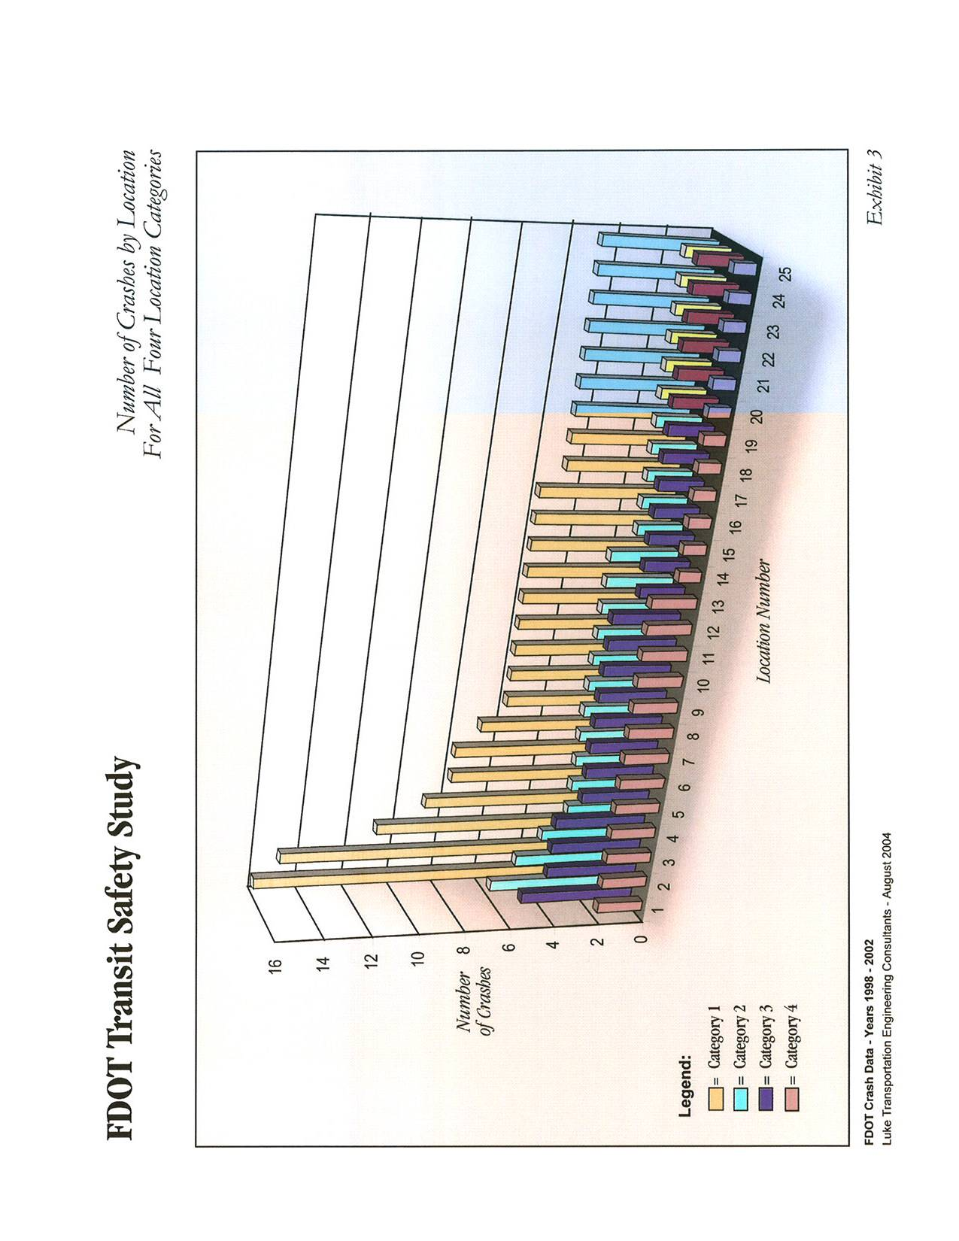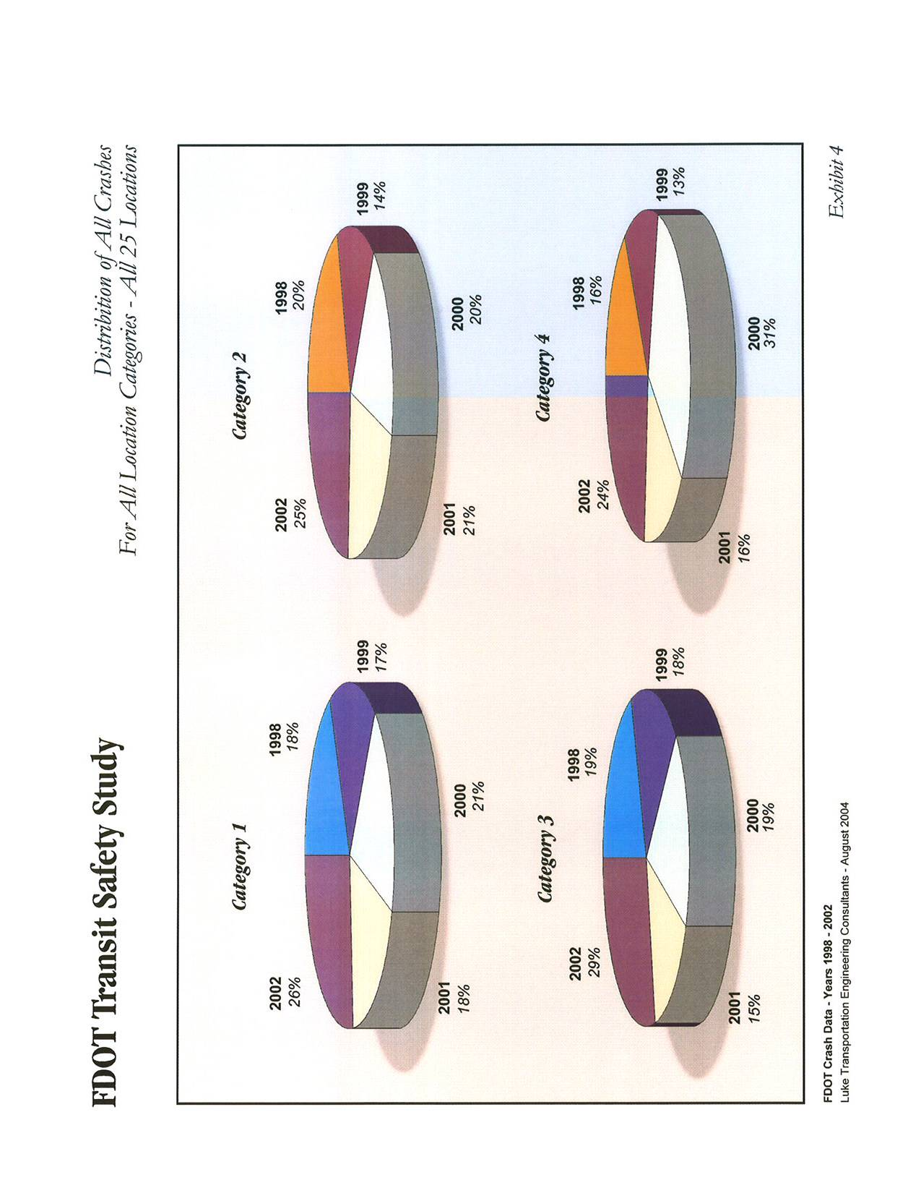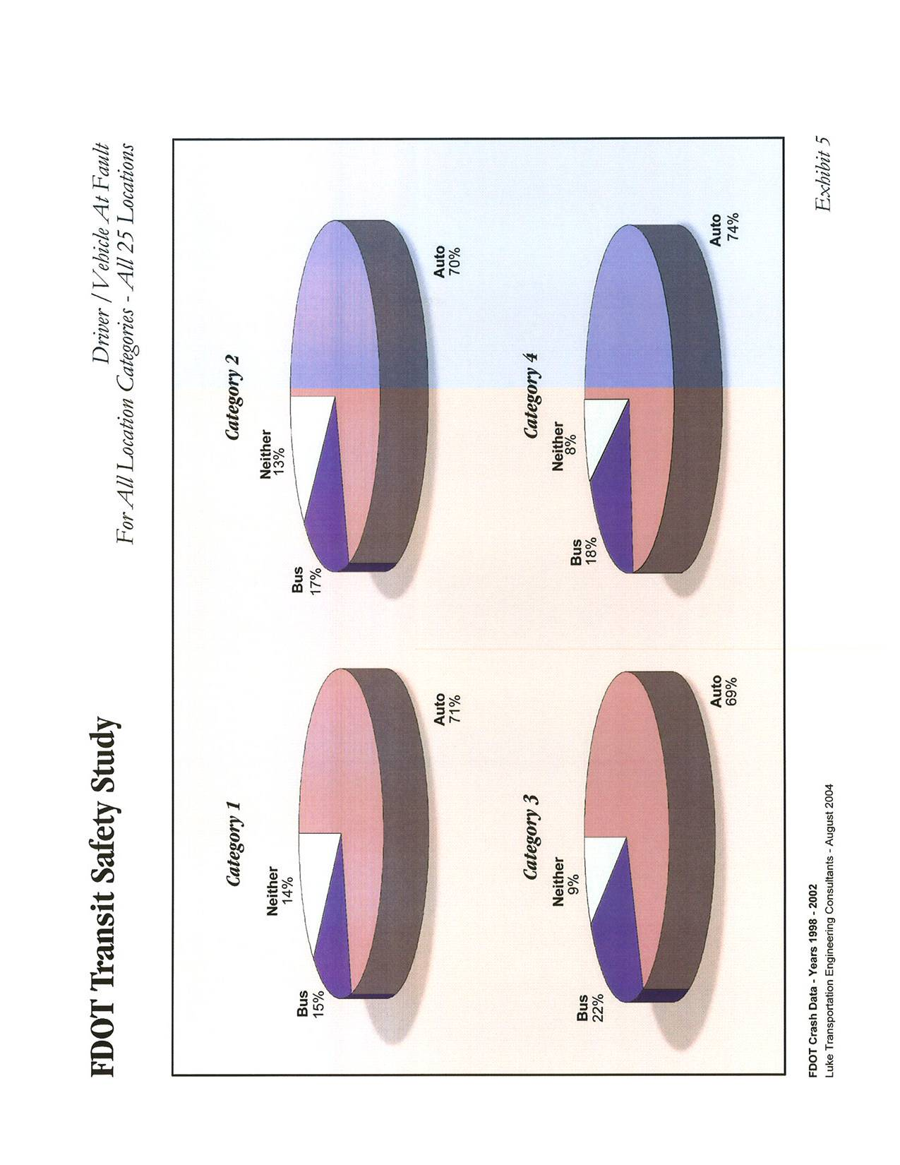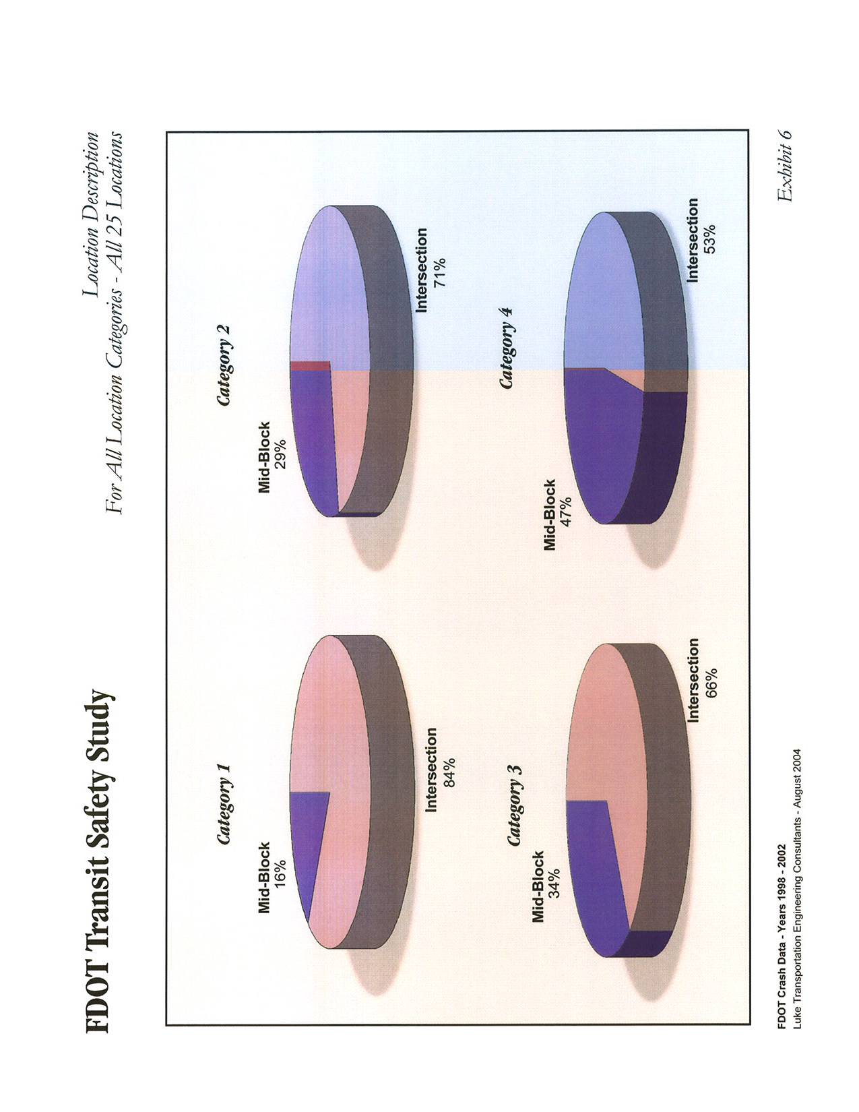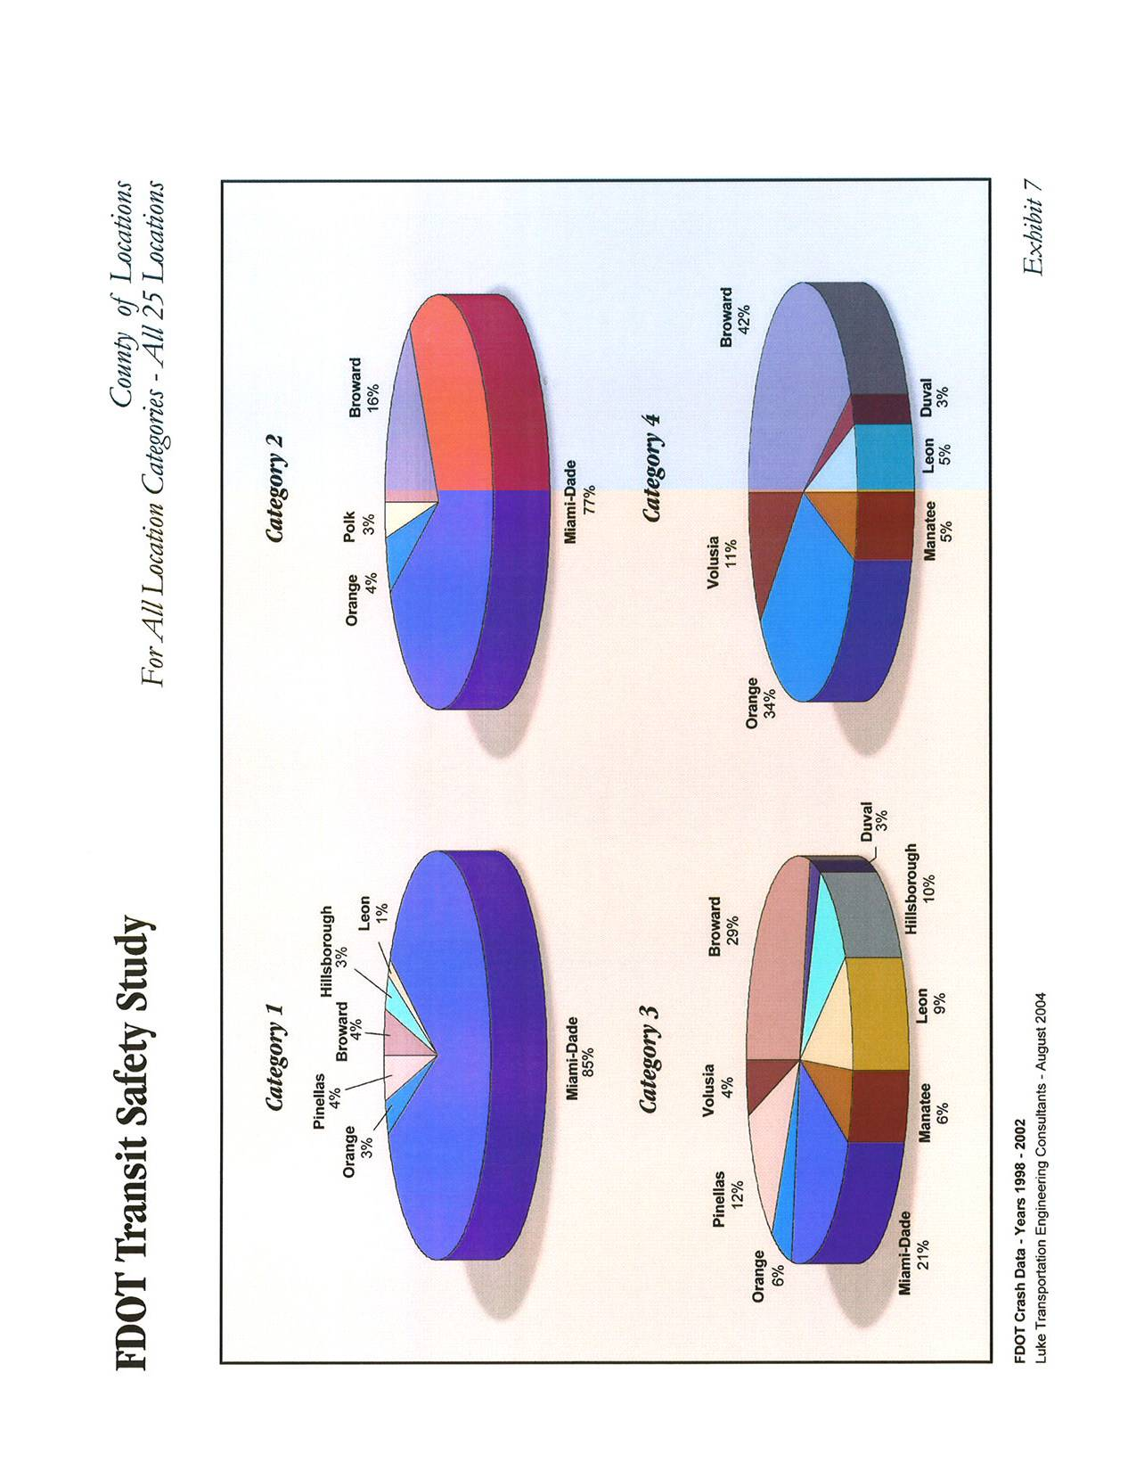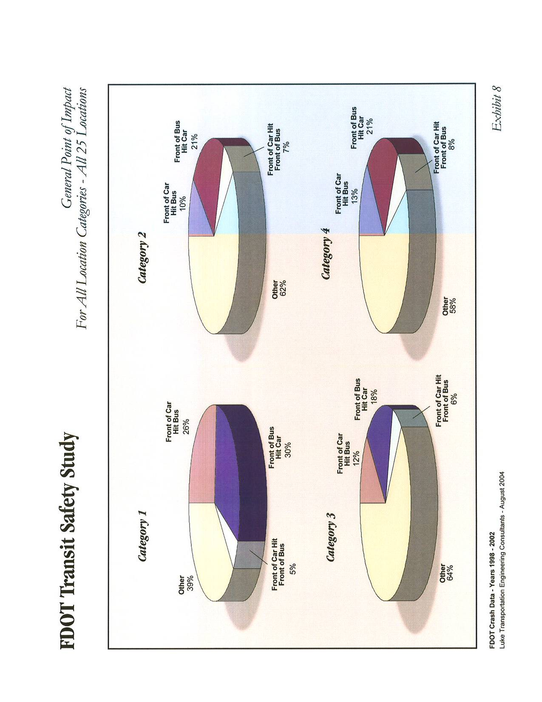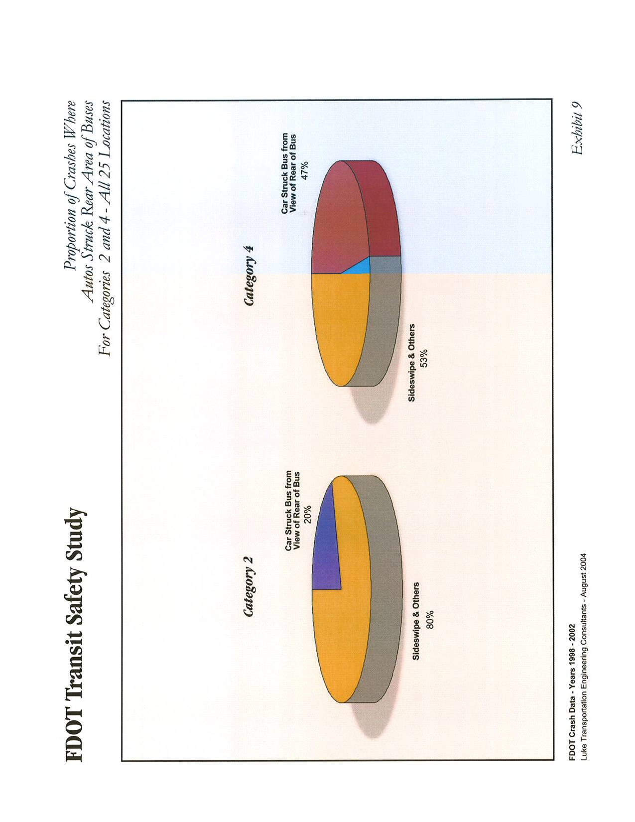
- Consistently, for the four (4) categories, most of the crashes were reported to have occurred at an intersection. Between 53% and 84% of the crashes were at an intersection, as opposed to mid-block. This indicates that the greater number f vehicular conflict points associated with an intersection is a major factor in the probability of a crash occurring with a bus.
- Exhibits 7 and 10 indicate the counties in which the high-accident locations are located. For Categories 1, 2, and 3, the densely developed areas of Miami-Dade and Broward Counties are between 50% and 93% of the top locations are located. The locations for Category 4 are not as meaningful, since the top locations for this category only had up to two (2) crashes per location. Appendix H contains enlarged maps of the highest accidents areas. In addition, Appendix H contains field photographs of selective high-accidents locations for Categories 2 and 4.
- Exhibit 9 identifies the portion of more severe accidents (Categories 2 and 4) that was judged to involve an auto at fault that was within view of the rear of the bus during the incident. This suggests that a portion of crashes that may have been affected by improved visibility of the rear of the bus. It should be understood that this representation is based on the evaluation of the general crash diagrams and the judgment of the researchers of this study. Note that 20% (Category 2) and 47% (Category 4) of these crashes appear to be within the visual influence or the rear of the bus. Note that more of the crashes of this type appear to occur at or near bus stops (Category 4). This observation supports the consideration of the lighting/marking configuration of the rear of the bus as a design component assessed in this study.

3.0 TRANSIT SYSTEM ACCIDENT DATA
3.1 Purpose and Approach
In order to obtain a diverse database in this study, the scope of work involved an effort to coordinate directly with all of the transit agencies in Florida to assemble data and input relating to accident and safety trends for each transit system. In order to accomplish this, surveys were conducted with each of the transit agencies. This section summarizes the effort completed to obtain the data and input from the transit agencies.
The purpose of the survey was twofold:
- To collect quantitative accident/injury/fatality information from each of the transit agencies for the most recent available three (3) years - this was found to be, in most cases, records for years 2001, 2002, and 2003 of the National Transit Database (NTD) data. Based on procedures from the Federal Transit Administration (FTA), it was found that the various agencies utilized different procedures and standards in tracking transit accidents.
- To collect qualitative information, both objective and subjective, from a number of highly experienced experts who plan, maintain, and operate transit systems throughout Florida that could be incorporated in FDOT design considerations that would eliminate or reduce accidents at transit stops, routes, and stations. Qualitative information included such input as opinions on contributing factors to transit-related accidents, thoughts on roadway design, or other recommendations that may help improve safety on transit systems.

3.2 Transit Agency Surveys

3.2.1 Methodology
A list of transit agencies in the State of Florida was obtained from the American Public Transportation Association’s web site at (http://www.apta.com/links/state_local/fl.cfm). A total of twenty-eight agencies were identified. The counties of the agencies are indicated in Exhibit 1. Based on the number of boardings per year, some of the agencies, which served large urban areas, were categorized as “major” transit systems within Florida. The major systems normally operated with more than 2-million boardings per year. Nine (9) of the twenty-eight agencies were considered to be major systems. It was determined that, at a minimum, all of the major system agencies would be surveyed in person. It was assumed that the quality of the data and information gathered would be enhanced and more beneficial if the interviews were conducted in person.
Procedurally, each of the agencies’ directors/ general managers’ office was contacted to explain the purpose of the study and to identify key personnel to complete the survey. It was found, that the survey responses were most often handled by personnel in the Operations Department or the Safety and Security Divisions. These key individuals were contacted and were explained the purpose of the survey. Subsequently, the survey, (see appended sample, Appendix I) was either forwarded via facsimile or via e-mail for completion. On-site interview meetings were scheduled with the major transit agencies.
The remaining agencies were asked to return the survey forms and then a telephone interview would be scheduled. Once the surveys were received, the respective contact person was contacted via telephone and an interview was conducted for any additional information that would be beneficial to the analysis.
The transit agencies were found to be very cooperative and informative. While complete surveys were obtained for most of the agencies, some responses were not complete. In some cases, the agency staff did not have the survey responses information readily available, or the specific personnel who could answer the survey questions were not available at the time of the survey. It was determined that the overall effort served to provide the qualitative input and trends from the transit agency staff.

    - Develop Survey Instrument

A survey instrument (Appendix I) was developed to elicit key safety and operations data from transit agency personnel at each public transit agency. The survey instrument included eleven questions regarding bus transit safety data, worst accident locations, contributing factors to accidents, factors used in siting bus stops, types of bus stops, design standards for bus stops, and transit agency sponsorship of bicycle or pedestrian facilities. The survey instrument also briefly explained the purpose of the Transit Safety Study, listed key agency contact persons, and provided directions for responding by fax, mail, or e-mail. This survey instrument was reviewed with FDOT Project staff prior to its utilization in the survey.

3.2.3 List of Agencies

The following lists the twenty-eight transit agencies identified in the State of Florida.

Major Transit System Agencies
LeeTran, (Lee County, Fort Meyers)
Jacksonville Transportation Authority, (Jacksonville)
Broward Co. Division of Mass Transit, (Broward County, Ft. Lauderdale)
Gainesville Regional Transit System, (Gainesville)
Miami-Dade Transit, (Miami)
Orlando LYNX, (Orlando)
TALTRAN, (Tallahassee)
HARTline Hillsborough Area Regional Transit Authority, (Tampa)
Volusia County Transportation Authority, (Daytona)

Other Transit Agencies
Polk County Transit Services Division, (Bartow)
Space Coast Area Transit, (Brevard)
Escambia County Area Transit, (Pensacola)
Okaloosa County Transit, (Fort Walton Beach)
Trans-Hernando/Mid-Florida Community Services (Brooksville).
City of Key West - Dept. of Transportation, (Key West)
Citrus Connection Winterhaven Mass Transit, (Winter Haven)
Manatee County Area Transit, (Bradenton)
Pasco County Public Transportation, (New Port Richey)
Ocala Marion Transit dba SunTran, (Ocala)
Palm Tran, (Palm Beach)
Bay County Council On Aging, (Panama City)
Pinellas Suncoast Transit Authority, (Clearwater)
Community Transit/Council on Aging, (Port St. Lucie)
Sarasota County Area Transit, (Sarasota)
Indian River County Council on Aging, Inc., (Vero Beach)
Council on Aging of Martin County, (Stuart)
Live Oak, (Suwannee County)
Collier Area Transit, (Naples)

3.2.4 Interview Approach
As noted in the methodology above, each agency was contacted to explain the purpose of the survey and to schedule the survey. It was stressed to each agency that their participation was key to the success of the study and that the ultimate goal of the study, identified by FDOT, was to determine design considerations to State and Federal Highway Systems that would improve transit safety and operations. The agencies were found to be very cooperative and interested in the study. Appendix I lists the agency contact information and general interview schedule.
Interview responsibility was split between the project team members: John Mason, Tony Luke, and Kim Brown. In order to insure consistency, the first three (3) interviews were conducted by all three (3) team members. These interviews included Gainesville RTA, Orlando LYNX, and Tampa HARTline. As these agencies had received the survey form in advance they came to the meeting with completed survey forms in hand. The interviewers went question by question through the survey to a) ensure the question was understood, b) to understand where the data came from, c) to give the interviewee an opportunity to elaborate and provide additional valuable information and d) to identify other questions or concerns that may not have been addressed in the survey.
The interviews at Broward, Miami, and Palm Beach were also conducted by all three (3) team members, due to the size of said agencies. All telephone interviews were conducted in similar manner.

3.2.5 Interview Survey Results

The following fourteen agencies were surveyed in person at the respective agencies facility:
Gainesville Regional Transit System, (Gainesville)
Orlando LYNX, (Orlando)
HARTline Hillsborough Area Regional Transit Authority, (Tampa)
Palm Tran, (Palm Beach)
Broward Co. Division of Mass Transit, (Broward County, Ft. Lauderdale)
Miami-Dade Transit, (Miami)
LeeTran, Lee County, (Fort Meyers)
Escambia County Area Transit, (Pensacola)
Jacksonville Transportation Authority, (Jacksonville)
TALTRAN, (Tallahassee)
Pinellas Suncoast Transit Authority, (Clearwater)
Sarasota County Area Transit, (Sarasota)
Manatee County Area Transit, (Bradenton)
City of Key West - Dept. of Transportation, (Key West)

The following four (4) agencies were surveyed over the phone after completion of the survey form:
Pasco County Public Transportation, (New Port Richey)
Ocala Marion Transit dba SunTran, (Ocala)
Bay County Council On Aging, (Panama City)
Community Transit/Council on Aging, (Port St. Lucie)

Completed survey forms were received from the following three (3) agencies; however, telephone interviews were not conducted, as contacts were not available prior to completion of the study:
Space Coast Area Transit, (Brevard)
Okaloosa County Transit, (Fort Walton Beach)
Polk County Transit Services Division, (Bartow)
Volusia County Transportation Authority, (Daytona)

Complete survey forms were not obtained from a few of the smaller transit agencies. These included:
Indian River County Council on Aging, Inc., (Vero Beach)
Council on Aging of Martin County, (Stuart)
Citrus Connection Winterhaven Mass Transit, (Winter Haven)
Trans-Hernando/Mid-Florida Community Services. (Brooksville)

Two (2) agencies could not be contacted:
Live Oak, (Suwannee County)
Collier Area Transit, (Naples)

Completed survey forms from the transit agencies are provided in Appendix I.

3.2.6 Summary of Interview Survey Data
While complete survey input from some of the smaller agencies was not obtained, the survey information was received from the largest of the transit agencies around the state. A great deal of very useful input was obtained, and the effort served to accomplish the research study goals.
Results of the survey data are provided in Exhibit 11. It was found that NTD data was not available from the FTA for the last three (3) years at the time of this study. - The latest years had not yet been compiled by FTA at the time of this study. Therefore, this survey effort represented an opportunity to collect more recent accident data for 2001, 2002, and 2003; specifically, total number of accidents (Question 1) number of employee injuries or fatalities (Question 2), number of passenger injuries or fatalities (Question 3), and number of non-passenger injuries or fatalities (Question 4). Some agencies had the NTD data readily available and supplied that information. Some agencies supplied total numbers, not NTD data, and some weren’t able to provide any accident-related data at all. Consequently, a direct comparison of the data between the various agencies was not possible. The detailed analysis of the NTD data for the years 1995 through 2001 is provided later in this report. Trends identified through review of the responses to the surveys are identified in Section 3.2.7 below. Contact information and other observations are included in Exhibit 11, in addition to the results of the survey questionnaire.

3.2.7 Trends
Due to the wide variation in standards of quantitative data provided by the agencies, it was difficult to determine overall trends relating to the volumes of incidents. However, the following observations were made:
- The greatest number of accidents occurred in the more urban transit systems. Less urban transit systems tended to have lower accident rates.
- Most every transit agency reported that the largest cause of the accidents involving their buses was improper or inattentive actions on the part of private automobile drivers. Driver distractions, such as cell phones, were repeatedly raised as problems by the transit agency staff.
- Another common discussion related to bus pull-out bays provisions and operations. A number of transit agency staff felt that automobile drivers were either unaware of or were ignoring the law requiring that they yield to buses entering the travel lane from pull-out bays. Specifically, Florida Statute (Chapter 316/Section 0815) states:
  - The driver of a vehicle shall yield the right-of-way to a publicly owned transit bus traveling in the same direction, which has signaled and is reentering the traffic flow from a specifically designated pull-out bay.
  - This section does not relieve the driver of the public transit bus from the duty to drive with due regard for the safety of all persons using the roadway.
With regards to the quantitative portion of the survey (Questions 5 through 11), the following observations were made:
Each agency was asked to identify the three (3) worst locations involving transit accidents (Question 5). These locations were typically highly congested corridors. Most agencies agreed that the contributing factor to transit involved accidents was driver error general traffic (Question 6). These accidents were described as being “rear-enders” or “side-swipers”. The second most contributing factor was traffic conditions (i.e. congestion). Other highly ranked contributing factors included driver error-bus operators, roadway design, and transit stops/station locations. In siting bus stops on state and federal highways, most agencies considered proximity to neighborhoods or businesses as the most important factor (Questions 7). The type of bus stops at signalized intersections varied from city to city (Question 8). Out of 18 transit agency responses, six (6) agencies stated near-sided stops as their most popular, four (4) stated far-sided stops, seven (7) stated that it depends on the specific site, and one stated “other non-specific.”
Most of the transit agency survey responses indicated that they do have bus stop design standards. About one-third of the respondents indicated that they did not (Question 9). Design standards for several of the agencies were collected. These standards varied in content and format. The standards assembled will be utilized in the next phase (implementation) of this FDOT Project.
Regarding sponsoring or implementing bike/pedestrian facilities, most agencies indicated that they have never sponsored or constructed bicycle or pedestrian facilities to improve access to bus stops (Question 10). Most of the agencies informed us that the construction and maintenance of these facilities were the responsibility of other government agencies (i.e. Planning Department, MPO, etc.). Only Broward, Miami-Dade, Clearwater, and Brevard noted that they have implemented bike-rack-on-bus programs, bus racks at terminals, and/or sidewalks for pedestrian overpasses to reduce injuries near transit stops.
When asked specifically for other ways to improve safety through roadway design attributes (Question 11), the most common three (3) answers were widen the lanes, install pull-outs at major roadways, and institute designated transit lanes. Other suggestions were to provide for more effective marked transit stops, (i.e. flashing lights, advance signage, and marked curbs, etc) and design standards that are consistent statewide.
In addition to the survey questions, each agency was asked for suggestions for improved safety other than roadway design. The most common answer was public information awareness programs to educate the public that by law following automobiles required to yield to buses as they re-enter the roadway. Another suggestion was to conduct research to improve the visibility of the back of the bus, so as to better draw the attention of auto drivers following the bus. This could include such equipment as reflectors, brake lighting, strobe lights, and flashing lights, etc. The final suggestion was for all agencies to incorporate the Federally acknowledged training program, “Train-the-Trainer”, into their on-going employee education program. This program is designed specifically to educate the bus drivers on how to improve their driving skills so as to be more “defensive”.
In addition to the survey questions, the following observations were made during the interviews. None of the agencies identified locations on SHS where bus crashes occurred with great frequency. Transit agency staff surveys throughout the state generally supported the installation of bus pull-out bays on state roads. For the most part, those with reservations were concerned with the ability of buses to re-enter state roads in congested traffic areas. Most every agency had researched to some degree and/or evaluated use of lighting configurations on the rear of buses to alert following motorists. Some of the agencies implementing lighting equipment on the buses claim to have had noticeable reduction in traffic accidents. Such agencies were found to be in the less urban areas while the agencies in the more urban areas (Broward, Miami-Dade) found that these preventive measures had no impact at all.

3.2.8 Summary
This survey effort provided valuable qualitative information from seasoned transit planners and operators of most of the transit agencies in the State of Florida. The survey data confirms the State Highway Accident Data Analysis and the analysis of the NTD reported accident data; specifically, 1) there are no locations in the SHS where bus crashes occur with great frequency; 2) the biggest cause of crashes with buses was inattentive or careless driving on the part of private automobile operators (i.e. rear-end collisions or “side-swipers.”); and 3) the greatest number of accidents occurred in the more urban transit systems (i.e. Miami-Dade and Broward County) due to local traffic conditions (congestion); less urban transit systems tended to have lower accident rates.
Transit agency staff surveyed throughout the state generally suggested and/or supported the following as measures to improve transit safety of SHS: 1) installation of more bus pull-out bays on state roads; 2) more effectively marked transit stops; 3) more effective lighting configurations on the rear of buses; 4) public awareness programs to better inform motorists of Florida law to yield to buses entering the travel lane from a bus stop or station; 5) State-wide bus stop design standards and 6) State-wide employee training of defensive driving standards.

3.3 Analysis of National Transit Database Safety Data

Public transit systems, in Florida and across the United States, have developed and implemented programs designed to improve the safety of their passengers, employees and the general public. The safe operation of public transit vehicles is of utmost importance to the transit agency, its’ employees and passengers. Today, twenty-seven urban bus systems (fixed route, fixed schedule) operate within the State of Florida. An analysis of National Transit Database (NTD) data, which is reported annually by public transit systems to the Federal Transit Administration (FTA), was conducted in order to identify and to evaluate trends in transit safety.
While the NTD represents a quantitative source of transit accident data, it cannot be directly compared to the database generated from the FDOT crash data. Come trends in trends in distribution throughout the state and overall changes in total incidents by year can be drawn.

3.3.1 NTD Data Collection and Reduction

FDOT has developed software to retrieve and analyze NTD data for every transit system in the U.S. through a contract with the Lehman Center for Transportation Research, Florida International University. The Florida Transit Information System Version 2003 (FTIS 2003) software was used to download and analyze safety data reported by each of the motor bus (MB) transit systems in Florida. Motor bus service refers to fixed route, fixed schedule bus transit operations; motor bus service does not include either fixed guideway (e.g., light rail transit, automated guideway, heavy rail transit or commuter rail) or demand response service.
Safety data was first reported by transit systems in their NTD reports in fiscal year 1995 (Form 405-1). In 2000, the FTA undertook the most comprehensive revision to NTD safety reporting in over ten (10) years, replacing Form 405. Under the new reporting system, substantial changes have been made to both the scope and type of information reported prior to 2002. By mid-2003, all transit agencies had submitted at least one (1) full year of data to the FTA; however, at the time of this report, access to the data was not yet publicly available. Therefore, the analysis years for this report are 1995 through 2001.
Selected safety measures for twenty-four Motor Bus systems were collected and analyzed for fiscal years 1995 through 2001. These systems are listed below.
- Manatee County Area Transit
- Pinellas Suncoast Transit Authority
- Lee County Transit
- Broward County Mass Transit Division
- Gainesville Regional Transit System
- Lakeland Area Mass Transit District – Citrus Connection
- County of Volusia (VOTRAN)
- Miami-Dade Transit
- Central Florida Regional Transportation Authority (LYNX)
- City of Tallahassee (TALTRAN)
- Palm Tran, Inc.
- Escambia County Area Transit
- Jacksonville Transportation Authority
- Hillsborough Area Regional Transit Authority
- Sarasota County Transportation Authority
- Smyrna Transit System
- Space Coast Area Transit
- City of Key West Department of Transportation
- Pasco County Public Transportation
- Bay County Council on Aging – Bay Coordinated Transportation
- Indian River County Council on Aging
- Ocala Marion Transit dba Sun Tran, (Ocala)
- Polk County Transit Services Division
- Okaloosa County Board of Commissioners

NTD Form 405-1 includes 134 safety-related variables that are reported by transit agencies. FTA specifies the following seven (7) broad categories of reportable incidents, fatalities, and injuries. Any incident, fatality or injury, then, is reported by the transit agency according to one of these seven (7) categories.
Safety Categories (7):
- Number of Incidents. Total number of unforeseen occurrences resulting in casualty (injury/fatality), collision, or property damage in excess of $1,000. For an incident to be reportable, it must involve a transit vehicle or occur on transit property.
- Fatalities – Patrons
- Fatalities – Employees
- Fatalities – Other
- Injuries – Patrons
- Injuries – Employees
- Injuries – Other

Of the nineteen accident descriptions on Form 405-1, the following fifteen descriptions apply to Motor Bus:
Accident Descriptions (15):
- Collisions with Other Vehicles
- Collisions with Other Vehicles (At Grade Crossings)
- Collisions with Objects
- Collisions with People
- Attempted / Successful Suicides
- Derailments / Buses Going off Road
- Parking Facility
- Inside Vehicle
- On Right of Way (ROW)
- Boarding / Alighting Vehicle
- Associated with Lifts
- In Stations / Bus Stops
- Fires in Vehicles
- Fires in Stations
- Fires in ROW and Others

In attempting to identify trends in transit safety, the safety variables were aggregated to a more manageable number; trends simply would not be evident when individual safety measures are examined. Next, recognizing that total incidents, fatalities or injuries don’t reflect varying LOS supplied or consumed, derived variables have been developed for total incidents, fatalities or injuries per unit of service supply (e.g., annual revenue vehicle miles) and service consumed (e.g., annual passenger miles).

3.3.2 All Florida Transit Systems – MB Incidents, Fatalities, and Injuries

In attempting to identify trends in transit safety on the system level, the evaluation focused on Total MB Incidents (Exhibit 12), Total MB Fatalities (Exhibit 15), and Total MB Injuries (Exhibit 18). Next, recognizing that total incidents, fatalities or injuries do not reflect varying LOS supply or service consumed, derived variables were developed for Total Incidents, Total Fatalities and Total Injuries per unit of service supply and per unit of service consumed. Annual Total Actual Vehicle Revenue Miles represented service supply (Exhibits 2, 5 and 8). Annual Passenger Miles represented service consumed (Exhibits 3, 6 and 9). Data for all twenty-nine MB systems was aggregated for each reported year: 1995 through 2001.

Exhibit 12 MB Incidents

Exhibit 13 MB Incidents per Million Vehicle Miles

Exhibit 14 MB Incidents per Million Passenger Miles

Exhibit 15 MB Fatalities

Exhibit 16 MB Fatalities per Million Vehicle Miles

Exhibit 17 MB Fatalities per Million Passenger Miles

Exhibit 18 MB Injuries

Exhibit 19 MB Injuries per Million Vehicle Miles

Exhibit 20 MB Injuries per Million Passenger Miles

- Incidents. The total number of incidents reported by Florida transit agencies has increased from 1,545 in 1995 to 1,893 in 2001 (Exhibit 1). However, the rate of incidents in terms of Incidents per Million Vehicle Miles and Incidents per Million Passenger Miles has been fairly constant during this period (Exhibit 2 and 3). Interestingly, the rate of incidents for Florida transit agencies is less than the U.S. average in terms of service supplied (vehicle miles), but is higher than the U.S. average in terms of service consumed (passenger miles). This reflects the somewhat ridership per vehicle mile in Florida systems.

- Fatalities. Overall, there are few discernable trends in MB fatalities over the seven (7) year period due to fluctuations in serious accidents that result in fatalities. MB fatalities were very high ten (10) in 1996 and 1998, and very low two (2) in 1997 and 2001 (Exhibit 15). One (1) or two (2) major accidents in any given year could skew the Total Fatalities. In other words, the sample size is too small and the data is too “lumpy”.

- Injuries. Annual MB Injuries increased from 1995 (1,485) to 1999 (1,909), then declined slightly in 2000 and 2001 (Exhibit 19). Overall, most MB Injuries involve transit patrons. When considering MB Injuries per unit of service supply (Exhibit 8) or service consumed (Exhibit 20), Florida MB Injury rates are very similar to the U.S. average. Injury rates per vehicle mile and per passenger mile have remained fairly constant during the analysis period.

3.3.3 All Florida Transit Systems – Accidents by Type

The goal of the next phase of analysis was to disaggregate the Florida MB transit system data to determine the most frequently occurring accidents by type. The most prevalent accident types for the fifteen safety variables were (percentage is cumulative FY 1995 through FY 2001):

- Collisions with Other Vehicles (46.3%)
- Collisions Inside Vehicle (24.2%)
- Boarding / Alighting Vehicle (12.7%)
- In Stations / Bus Stops (7.1%)
- Collisions with Objects (4.0%)
- Collisions with People (2.7%)
- Associated with Lifts (0.8%)
- Parking Facility (0.7%)
- Fires in Vehicles (0.4%)
- On Right of Way (0.4%)
- Fires (ROW and Others) (0.3%)
- Collisions at Grade Crossings (0.2%)
- Bus Going Off Road (0.1%)
- Fires in Stations/Bus Stops (0.1%)
- Attempted/Successful Suicides (0.0%)

(Percentages may not add to 100.0% due to rounding)

Exhibit 21 depicts all accidents by type for the seven-year period.

Exhibit 21 MB Accidents by Type

In addition, a trend analysis for each safety variable was performed to evaluate the change in the number of accidents from 1995 to 2001. Exhibit 22 through 25 display the trends for the four (4) most frequently reported types of accidents: Collisions with Other Vehicles, Inside Vehicle, Boarding / Alighting Vehicle, and In Stations / Bus Stops.

Exhibit 22 Collisions with Other Vehicles

Exhibit 23 Inside Vehicle

Exhibit 24 Boarding / Alighting Vehicle

Exhibit 25 In Stations / Bus Stops

Two (2) of the safety variables experienced a rising trend during the period 1995 to 2001:

- Collisions with Other Vehicles. A sharp rise from 652 incidents in 1995 to 932 incidents in 2001, a 30% increase. Further analysis reveals that Miami-Dade was the largest contributor to this accident type, followed by Broward County and CFRTA-Orlando. (Exhibit 22)

- Boarding / Alighting Vehicles. A slight rise from 203 incidents to 252 incidents, a 21% increase during the seven (7) year period. Additional analysis indicates HART, CFRTA-Orlando, and Miami-Dade as the largest contributors to the increase. (Exhibit 24)

Two (2) safety variables denote a constant or flat trend during the period 1995 to 2001:
- Inside Vehicle. A constant trend of roughly 425 incidents per year. (Exhibit 23)

- In Stations / Bus Stops. A flat trend of around 125 incidents per year. (Exhibit 25).

3.3.4 Comparative Analysis – Accident Rates for Largest Transit Systems (2001)

The last phase of analysis involved a comparison of accident rates per unit of service supplied in 2001 for the four (4) most frequently occurring accident types: Collisions with Other Vehicles, Inside Vehicle, Boarding / Alighting Vehicle, and In Stations / Bus Stops.

Eight (8) transit systems consistently experienced the highest number of incidents across all variables. These systems are:
- Miami-Dade Transit (Miami-Dade)
- Broward County Mass Transit Division (Broward County)
- Central Florida Regional Transportation Authority (CFRTA-Orlando)
- Jacksonville Transportation Authority (Jacksonville)
- Pinellas Suncoast Transit Authority (Pinellas Suncoast)
- Hillsborough Area Regional Transit Authority (HART)
- City of Tallahassee (TALTRAN)
- Lee County Transit (Lee County)

For uniformity of analysis, a derived variable for each accident type was developed per unit of service supply according to the following formula:

Accident Rate = Number of Incidents / Actual Annual Vehicle Revenue Miles

Data for a total of four (4) variables was collected, graphed and analyzed. These graphs are shown in the Exhibits 26 through 29 on the following pages.

Exhibit 26 Collisions with Other Vehicles (2001)

Exhibit 27 Inside Vehicle (2001)

Exhibit 28 Boarding/Alighting Vehicle (2001)

Exhibit 29 In Stations / Bus Stops (2001)

Broward County and Miami-Dade had the highest accident rates for Collisions with Other Vehicles (Exhibit 26). Many of the systems reported incidents for Inside Vehicles, with HART and Jacksonville among the highest accident rates and Lee County with the lowest accident rate (Exhibit 29). Three (3) transit systems produced the highest accident rates for Boarding / Alighting Vehicle: HART, Jacksonville, and Broward County (Exhibit 28). Miami-Dade had the highest accident rate for In Stations / Bus Stops, far above all other systems (Exhibit 29).

It is clear that there is not consistent reporting of accidents by type among the transit agencies. Therefore, caution must be used when comparing accident rates among transit agencies by type.

3.3.5 Summary

This analysis of NTD reported accident data confirm the survey interviews conducted with each of the major transit agencies – that is, the most prevalent cause of accidents is collisions with other vehicles. Each transit agency that was interviewed listed collisions with other vehicles, and in particular rear-end collisions (i.e., cars run into rear of bus), as the major cause of accidents involving motor buses. Several of the transit agencies have taken proactive steps to reduce the number of rear-end collisions, including mounting multiple deceleration lights on the rear of the bus.

This analysis also confirmed the hypothesis that the more urban transit systems (e.g., Miami-Dade and Broward County) experienced the highest rates of accidents due to local traffic conditions. Smaller, less urban transit systems tended to have lower accident rates.

4.0 STUDY CONCLUSIONS AND RECOMMENDATIONS
The following major conclusions were reached through this research study:
- For serious crashes involving buses (Categories 2 and 4), the high-accident locations had low occurrences of crashes. For the top location, only just over one (1) crash per year occurred. This quickly dropped to less than one (1) crash per year for Locations 4 and beyond. Therefore, it was concluded that there were no locations on the SHS where bus crashes occur with great frequency.
- The data also indicated that locations near bus stops or stations did not experience high occurrences of bus crashes. The frequency of the bus crashes between Category 2 and Category 3 are very similar.
- The biggest cause of crashes with buses was inattentive or careless driving on the part of private automobile operators.
- In the case of most of the serious crashes (with injuries) near bus stops (Category 4), most of the autos struck the rear area of the bus.
- The greatest numbers of high-accident locations were found to be in southeast Florida, Miami-Dade, and Broward.
- Transit agency staff surveyed throughout the state generally supported the installation of more bus turn-out bays on state roads. For the most part, those with reservations about this were concerned with the ability of buses to re-enter the state road in congested traffic areas.
- Most every agency has researched and/or evaluated use of lighting configurations on the rear of buses to alert following motorists. Most of the agencies have implemented the lighting equipment on the buses.
As a result of these conclusions reached, recommendations were developed and discussed with the FDOT Project Manager. These recommendations were limited in scope to address the specific conclusions/problems identified through the research study. These recommendations were formulated with the realization that a second phase will follow this research study phase. The second phase will involve the development of specific tasks, designs, or practices to implement the general recommendations. These recommendations are:
  - Install more bus pull-out bays on state roads. The installation of more turn-out bays will require:
    - Evaluation of design standards for the turn-out bays,
    - Evaluation of costs for right-of-way and construction of the turn-out bays,
    - Determination of funding sources for construction of the facilities,
    - Analysis to identify locations and prioritization of construction of the facilities,
    - Coordination with the transit agencies relative to the placement and design of the facilities.
This research study has identified specific high-accident locations. This information can be applied to determine a prioritization of the construction of the pull-out bays.
Where state roads are congested or carry high-speed traffic, operational devices and/or controls may be installed to provide for the safe entry of buses into the state road travel lanes. A study should be completed to develop these devices and/or controls.
  - A specific study should be completed to improve and standardize the lighting configurations on buses. The purpose of the lighting configurations is to improve auto driver awareness of the presence and operation of the buses. This study should also serve to coordinate the practice of bus lighting configuration installations and use between all of the transit agencies throughout Florida.
  - An on-going public awareness effort should be initiated to better inform motorists of the Florida law that requires drivers to yield to buses entering the travel lane from a bus stop or station. FDOT should research and develop this effort to maximize its effectiveness. Strategies could include:
- Radio and television messages
- Inclusion of message with required driver education courses and license and tag renewals
- Message related through use of billboards and other signage
  - Standard informational signage could be developed to place on the SHS in areas where bus accidents are historically highest. This informational signage would state the law requiring motorists to yield to public buses entering the travel lane from a bus stop or station. As part of the next phase of this project, adopted FDOT signage standards could be reviewed and applied in the design of the informational signs.
As part of this study, the ACCESS crash database and mapping files have been provided to FDOT. These analysis tools can be utilized to expand or complete alternative evaluations of crash history. In addition, the identification of the high accident locations can be used to obtain and review additional data that would be informational regarding traffic safety and operations. The additional data could include traffic count and observations, review of the FDOT video logs, additional aerial plans, or driver and bus passenger surveys.
The next phase of the overall project will involve the development of a plan to implement these recommendations. The Project Team will coordinate with FDOT to develop a scope of work for the Implementation Phase. The approach and schedule for the Implementation Phase will also be determined subsequent to submittal of this study.

