**Subrecipient Quick Reference Guide**

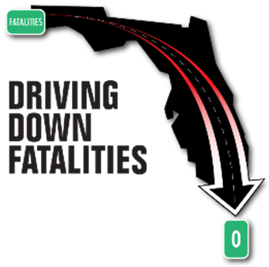

Florida Department of Transportation

State Safety Office

Highway Safety Subgrant Program

*Revised 11/2017*



Disclaimer 2

Deadlines 3

Personnel Services 4

Contractual Services 6

Expenses 8

Operating Capital Outlay (OCO) 13

Appendix

A. Reimbursement Claim Forms 16

B. Performance Reports 20

C. Incidental Expense Reference Sheet 23

D. Law Enforcement Activity Reports 24

**DISCLAIMER**

**INFORMATION PROVIDED IN THIS QUICK REFERENCE GUIDE IS A COMPILATON OF APPLICABLE STATE AND FEDERAL LAW AND SUBGRANT ACCEPTANCE AND AGREEMENT LANGUAGE.**

**ANY CHANGES IN STATE AND FEDERAL LAW AND SUBGRANT ACCEPTANCE AND AGREEMENT LANGUAGE OCCURING AFTER THIS PUBLICATION AND/OR EXCLUDED FROM THIS PUBLICATION DOES IN NO WAY EXCLUDE THE SUBRECIPIENT FROM COMPLIANCE WITH CURRENT LAWS AND EXECUTED ACCEPTANCE AND AGREEMENT TERMS**

**SAFETY OFFICE APPROVALS:**

All preapprovals must be submitted to the Safety Office, at least 14 business days in advance of travel, purchase, printing, etc. Failure to provide within this timeframe may result in denial of request.

The Safety Office has a 30-day review process of financial reimbursement requests from the date of receipt. Reimbursement requests will be returned if not completed properly.

**REIMBURSEMENT CLAIMS:**

Subgrants with Personnel Costs Monthly

Subgrants without Personnel Costs at least Quarterly

FINAL Reimbursement Claim by October 31st

A FINAL financial request for reimbursement shall be postmarked no later than October 31st following the end of the subgrant period. Such request shall be distinctly identified as Final. Failure to submit the invoice in a timely manner shall result in denial of payment. The Subrecipient agrees to forfeit reimbursement of any amount incurred if the final request is not postmarked by October 31 following the end of the subgrant period.

**REPORTS:**

Performance Reports Included with Each Reimbursement Claim

Final Narrative with Final Claim and prior to October 31st

The implementing agency shall submit a Final Narrative Report, giving a chronological history of the subgrant activities, problems encountered, and major accomplishments by October 31st. Requests for reimbursement will be returned to the subrecipient or implementing agency unpaid if the required reports are past due, following notification.

**RECEIPT GOODS AND SERVICES:**  September 30th

**CONCEPT PAPERS:** January 1st – February 28th

**GRANT PERIOD** Subgrant (Start) Date – September 30th

**PREREQUISITES:**

* **Personnel Letter** – a formal letter listing all employee names and titles working under the subgrant, should be received prior to submitting first claim or along with the first claim.
  + **Please note: Formal letters for changes to personnel or additions should also be submitted immediately prior to requesting reimbursement for employee(s)**
  + If your subgrant includes reimbursement of benefits, please include current rates used to calculate benefit(s) on your personnel letter.
  + Please provide this list in alphabetical order, if at all possible.
* **Personnel Hired Under the Subgrant** – The head of any implementing agency receiving first year funding for a new position(s) through a subgrant shall provide written notification within 30 days of the agreement being awarded to the Safety Office that a new position(s) has been created in the agency as a result of the subgrant being awarded.

**LEGAL LIMITATIONS:**

* Personnel hired under the subgrant shall not hold the position of **Project Director** nor receive any benefit under this subgrant.

**REIMBURSEMENT REQUIREMENTS:**

* Personnel hours will only be reimbursed based on actual hours that were worked on the subgrant. No other allocation method is allowable for reimbursement.
* Please define all acronyms that may occur on your payroll and benefits documentation (i.e. OT – Overtime; ST – straight time) by making a written note on the documentation.
* Please use legal names, as represented on payroll documentation, on all reimbursement forms.
* Benefits – all payroll documentations for employER paid benefits will need to be submitted with each claim **“only”** when requesting for reimbursement
  + - Examples of Benefits to include, but are not limited to**: Fringe Benefits, FICA, Workers Compensations, Retirement, etc.**
    - **If requesting benefits, please provide the current rate information (i.e. – Retirement is 23.27% through June 30th)**
* FDOT will only reimburse actual salary and benefit costs paid. Please be mindful when using an excel spreadsheet to calculate your reimbursement requests, your totals may round up. Rates are rounded to the hundredths decimal place ($0.XX) on either the result of a calculation (item rate multiplied by number of units) or the total invoice amount.

**PREREQUISITES:**

* **Approval** – The Safety Office **shall review and approve** in writing **all consultant and contractor agreements (CSA)** prior to the actual employment of the consultant or the contractor by the Subrecipient or implementing agency
* A **DRAFT** copy of the contractual service agreement must be provided to the safety office for approval **prior** to any signature execution.
* All contractual service agreements shall include as a minimum the following information:

1. Beginning and end dates of the agreement (not to exceed the subgrant period)
2. Total contract amount
3. Scope of work/Services to be provided
4. Budget/Cost Analysis
5. Method of compensation/Payment Schedule
6. All contractual service agreements shall contain the following statements:

“The parties to the contract shall be bound by all applicable sections of **Part V: Acceptance an Agreement** of Project # (**insert Project #**), DOT Contract # (**insert contract #**). A final invoice must be received by (**insert date**) or payment will be forfeited.”

1. Disadvantaged Business Enterprises (DBE) Consultant/Contractor Assurances (Found in Part V; Section 24)
2. Nondiscrimination Consultant/Contractor Assurances (Found in Part V; Section 46):

“During the performance of this subgrant, the Subrecipient agrees:

1. To comply with all Federal nondiscrimination laws and regulations, as may be amended from time to time
2. Not to participate directly or indirectly in the discrimination prohibited by any Federal non-discrimination law or regulation, as set forth in appendix B of 49 CFR part 2l and herein
3. To permit access to its books, records, accounts, other sources of information, and its facilities as required by the FDOT State Safety Office, US DOT or NHTSA
4. That, in event a Subrecipient fails to comply with any nondiscrimination provisions in this subgrant, the FDOT State Safety Office will have the right to impose such subgrant sanctions as it or NHTSA determine are appropriate, including but not limited to withholding payments to the Subrecipient under the contract/agreement until the Subrecipient complies; and/or cancelling, terminating, or suspending a contract or funding agreement, in whole or in part
5. To insert this clause, including paragraphs a through e, in every subcontract and sub-agreement and in every solicitation for a subcontract or sub-agreement, which receives Federal funds under this program”

**LEGAL LIMITATIONS:**

* Per Part V; Section 3: The subrecipient and implementing agency agree to comply with all applicable provisions of Chapter 287, Florida Statutes; especially sections 287.133(3)(a) and 287.134(3)(a)

**REIMBURSEMENT REQUIREMENTS:**

* Ensure that the invoice matches the method of compensation, as described in the approved CSA.

**PREREQUISITES:**

* **BUY AMERICAN** – Any manufactured product whose unit purchase price is $5,000 or more, including a motor vehicle, **MUST** be **MADE IN AMERICA**.

**PUBLIC INFORMATION AND EDUCATION ITEMS:**

* **Approval -** Before printing public information and education items, a final draft or drawing of the items must be submitted to the Safety Office for review and approval.
* All public information and education items reimbursed with subgrant funds shall contain a traffic safety message.
* Either the Florida Department of Transportation logo or the words “Funding provided by the Florida Department of Transportation” shall appear on all items.

**TRAVEL:**

* All out-of-state travel, conference travel, meeting travel which includes a registration fee, and out-of-grant-specified work area travel shall require written approval of the Safety Office prior to the commencement of the actual travel.
* Travel costs for approved travel shall be reimbursed in accordance FDOT Disbursement Operations Handbook, but not in excess of provisions in Section 112.061, Florida Statutes.

**MEAL RATES PER DIEM RATES**

|  |  |
| --- | --- |
| Breakfast - $6.00 | Before 6:00 am and extends beyond 8:00 am |
| Lunch – $11.00 | Before 12:00 pm and extends beyond 2:00 pm |
| Dinner - $19.00 | Before 6:00 pm and extends beyond 8:00 pm |

|  |  |
| --- | --- |
| 12:01 am – 6:00 am | $20.00 |
| 6:01 am –12:00 pm | $40.00 |
| 12:01 pm – 6:00 pm | $60.00 |
| 6:01 pm–12:00 pm | $80.00 |

**MILEAGE – Mileage reimbursement rate is 0.445 per mile (Round Down)**

* + When possible, the Department of Transportation Official Highway Mileage should be used to compute the mileage. <http://www2.dot.state.fl.us/CityToCityMileage/viewer.aspx>

You may use the map mileage available from on-line sources such as MapQuest or Google Maps. Copies of the map used, must be included with the reimbursement request.

* + When reimbursing actual mileage, the amount **must be rounded down**. For example, the calculation for a traveler claiming 157 miles would be: 157 x $0.445 = $69.865. The traveler could only be reimbursed a total of $69.86.
  + Vicinity mileage necessary for the conduct of official business is allowable for subsequent trips after arrival at the temporary duty location, but **can’t be added to the map mileage**. **Mileage to and from the traveler’s hotel and work site and to and from meals cannot be claimed as vicinity mileage**.
  + Travelers may claim vicinity mileage to and from airports or rental car locations, as authorized.
    - If travel occurs more than one hour before or after the traveler’s regular work hours, the point of origin may be the traveler’s residence. In this situation, the miles claimed must be the miles actually driven.
    - If travel occurs during the traveler’s normal work hours, the point of origin must be the closer of the traveler’s residence or headquarters.
* **The FDOT State Safety Office shall not pay for overnight lodging/hotel room rates that exceed $150.00 per night (before taxes and fees).**  A Subrecipient and/or traveler will be required to expend his or her own funds for paying the overnight lodging/hotel room rate in excess of $150.00 plus the applicable percentage of fees (other than flat fees). If multiple travelers share a room and the individual cost of the lodging/hotel exceeds the $150 per night limit, the Subrecipient and/or travelers will be required to expend his or her own funds for paying the excess amount. If another entity is covering the cost of the overnight lodging/hotel then this paragraph does not apply.

**Example 1:** The hotel nightly room rate is $175.00 and there is a $20.00 per night resort fee. The hotel stay was three nights. The breakdown of charges would be as follows:

$150.00 x 3 = $450.00 paid with state funds

$20.00 x 3 = $60.00 paid with state funds

$25.00 (amount over $150 nightly rate) x 3 = $75.00 paid with personal funds

**Example 2:** The hotel nightly room rate is $175.00 and there is a 2% per night surcharge. The hotel stay was three nights. The breakdown of charges would be as follows:

$150.00 x 3 = $450.00 paid with state funds

$150.00 x 2% = $3.00 x 3 = $9.00 paid with state funds

$25.00 (amount over $150 nightly rate) x 3 = $75.00 paid with personal funds

$25.00 x 2% = $0.50 x 3 = $1.50 paid with personal funds

* Lodging less than 50 miles from traveler’s official headquarters is not eligible for reimbursement without written and approved justification.

**REIMBURSEMENT REQUIREMENTS:**

*PUBLIC INFORMATION AND EDUCATION ITEMS*

* Proof of receipt of all public information and education items shall be submitted to the Safety Office at the time of reimbursement request.

Note: Pictures of promo items with required logo is acceptable.

* A copy of the Safety Office approval must be included with the invoice for public information and education items.

*TRAVEL:*

* ALL travel reimbursement requests must include a **Consultant Travel Form or State of Florida Travel form** **signed** by both the traveler and supervisor.
* All travel must include receipts or a lost receipt form and proof of payment. (i.e.: providing only a credit card statement for a gas charge without a gas receipt is not sufficient).
* Travel forms **MUST** include:

1. Accurate dates of travel
2. Meals, Lodging/Per Diem, Mileage Rates per FDOT Disbursement Operations Manual **(**Provided in Legal Limitations section**)**
3. Justification for any car rental above “Compact” rate
4. Copies of all applicable invoices and receipts (hotel, rental car, airfare, etc)
5. Include receipts and/or justification for incidental expenses, as required (see incidental expense reference sheet)
6. Proof of payment to traveler
7. Include the source of your claimed mileage in the justification or as an attachment
8. Mandatory Parking at Hotels – If a hotel charges a mandatory fee for parking (free self-parking is not available), you must state that the charge was mandatory. The statement “mandatory parking fee” or “no free parking available” can be written on the hotel receipt or Travel Form as justification for the charge. When requesting reimbursement for mandatory hotel parking, separate the parking fee from the hotel room charge and list the parking fee under Incidental Expenses on the Travel Form.
9. Rental Car Charges beyond the travel dates**:** in the event your travel ends on Friday and you don’t return the rental car until the following date, or you pick up the rental car a day before travel, justification must be provided with the receipt to explain the extra charges.
10. All acronyms must be spelled out at least once. This can be handwritten on the documentation, if necessary.

* Travel to formal **Conferences requires** the following additional information/adjustments:

1. A copy of the Agenda(s) from the conference
2. A copy of your Safety Office Approval to Attend the Conference
3. If a meal is included in the registration fee, the meal allowance must be deducted from the reimbursement claim, even if the traveler decides for personal reasons not to eat the meal per FS 112.061(8)(a)5 and FS 112.061(11)(b)1.
4. A continental breakfast is considered a meal and must be deducted if included in a registration fee per Attorney General Opinion 081-53.
5. If there is no registration fee or the fee is waived, you still must submit the detailed agenda and deduct any meals that were provided during the conference

* Travel **Out of State requires** the following additional information/adjustments:

1. A copy of your Safety Office approval to travel out of state

**PREREQUISITES:**

* **Buy American** – Any manufactured product whose unit purchase price is $5,000 or more, or a motor vehicle, MUST be MADE IN AMERICA.
* **Equipment Costing more than $5,000 per item** – Any equipment purchased with subgrant funds costing over $5,000 must be approved by NHTSA. Be mindful if your estimated unit cost was less than $5,000, at the time of award; however, at time of purchase now exceeds $5,000, you will need to notify the Safety Office **PRIOR** to making the purchase, to allow time for this required approval.

**LEGAL LIMITATIONS:**

* **Repossession of Equipment -** Ownership of all equipment purchased with Federal highway safety funds rests with the subrecipient and its implementing agency; however, the USDOT maintains an interest in the equipment until the end of its’ useful life. Any equipment purchased with Federal highway safety funds that is not being used by the subrecipient or its implementing agency for the purposes described in the subgrant shall be repossessed by the State Safety Office, on behalf of the USDOT. Items that are repossessed shall be disbursed to agencies that agree to use the equipment for the activity described in the subgrant.
* **Disposition of Subgrant Purchased Equipment -** Equipment purchased with a unit cost of over $5,000 **requires a written request for approval to dispose**.
  + Equipment **with a fair market value less than $5,000** must may be retained, sold or otherwise disposed of without further responsibility to FDOT beyond the initial approval.
  + Equipment **with a fair market value in excess of $5,000** is still an invested property of FDOT; therefore, FDOT has the right to recoup an amount proportionate to its share of the original investment.

**REIMBURSEMENT REQUIREMENTS:**

* **All requests for reimbursement of OCO items having a unit cost of $5,000** or more and a useful life of one year or more shall be accompanied by a Non-Expendable Property Accountability Record (FDOT Form No. 500-065-09)

**Reimbursement of cost for these items will not be processed without receipt of this form.**

APPENDIX

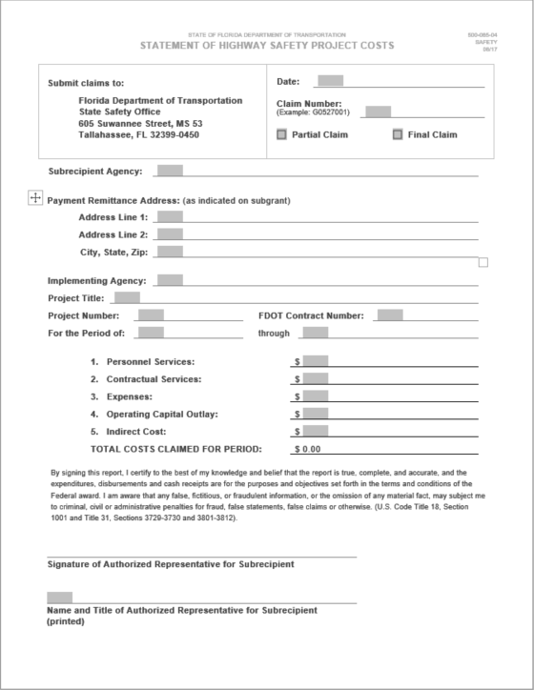

**Date:** The date the form is being completed

**Claim Number:** The FDOT contract number following a sequential numbering beginning with 001. (Example: Contract number APH30; claim 1 would be APH30001 and claim 15 would be APH30015)

**Partial/Final:** All claims are partial except for the final claim, which is explicitly marked as final.

**Subrecipient Agency:** The name and address of the Applicant Agency on the Subgrant Agreement

**Payment Remittance Address:** The address as stated in Part 11 of form (500-065-01).

**Implementing Agency:** The name of the Implementing Agency as stated on Part 4 of form (500-065-01).

**Project Titl**e: The project title indicated on the top of form (500-065-01)

**Project Number:** The project number indicated on the top of form (500-065-01)

**FDOT Contract Number:** The contract number indicated on the top of form (500-065-01). This is the five digit contract number and does not include claim number.

**For the Period of:** The period dates should represent earliest date worked or earliest date of expenditure through the latest date of payment. **The only exception is that the end date can never be after the end date of the subgrant which is September 30th. The start date of services can never be before the subgrant was executed.**

**Example:** Pay period 10/15-10/29 and all costs paid through October 31st would be stated as 10/15/2016 through 10/31/2016.

**NOTE: Dates entered here MUST match the dates provided on the Performance Report form (500-065-19).**

**Item 1:** This amount will come from the Summary Statement of Personnel Services Cost form (500-065-05).

**Items 2-5**: These amounts will come from the Detail of Costs form (500-065-07).

**Authorized Representative Signature:** Authorized Representatives are those persons who signed as agency administrators on the signature page of the subgrant agreement. Administrators may delegate signature authority **(Delegation letters must be provided)**

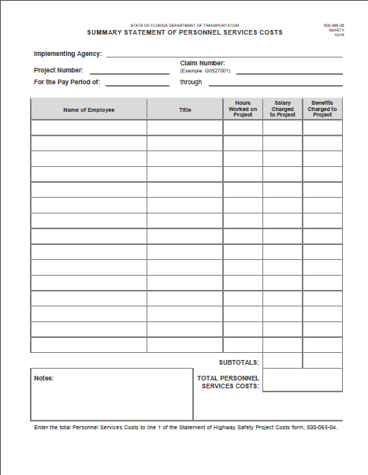

**Implementing Agency:** The name of the Implementing Agency on the Subgrant Agreement

**Project Number:** The project number indicated on the executed subgrant agreement.

**Claim Number:** The FDOT contract number following a sequential numbering beginning with 001. (Example: Contract number APH30; claim 1 would be APH30001 and claim 15 would be APH30015)

**For the Pay Period of:** The period reflects the beginning and ending dates of pay period being reimbursed, either bi-weekly or monthly.

**Name of Employee:** Name of employee as indicated on supporting payment documentation and personnel list provided.

**Title of Employees:** Title of employee as indicated in the subgrant and personnel list.

**Hours Worked on the Project:** Employee hours worked on subgrant.

**Salary Charged to Project:** Total cost requested for reimbursement for those hours worked on the subgrant.

**Benefits Charged to Project:** Total of benefits calculated for the hours worked on the subgrant.

**Notes:** Can be used to define acronyms or provide any necessary clarifications.

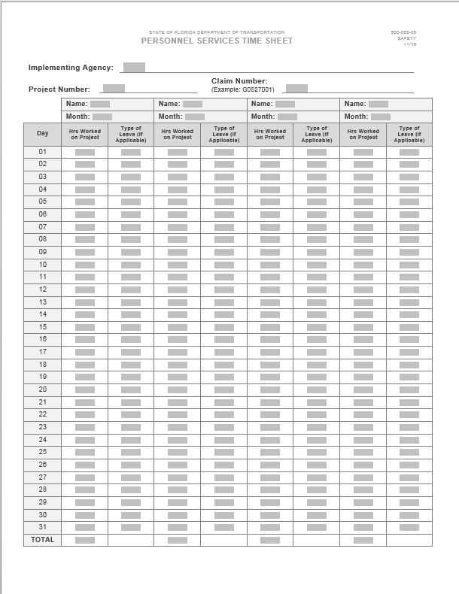

**Implementing Agency:** The name of the Implementing Agency on the Subgrant Agreement

**Project Number:** The project number indicated on the executed subgrant agreement.

**Claim Number:** The FDOT contract number following a sequential numbering beginning with 001. (Example: Contract number APH30; claim 1 would be APH30001 and claim 15 would be APH30015)

**Name:** The name of the authorized employee matching what is listed on 500-065-05. (List the personnel names in the same order as the Summary Statement of Personnel Costs form 500-065-05)

**Month:** The month the hours are being reported for.

**Hours Worked on Project:** Indicate the number of hours per day of the month worked on the subgrant project.

**Type of Leave (if applicable):** Personnel who are paid salary will reference type of leave as “Annual”, “Sick”, “Comp”, etc. THIS DOES NOT APPLY TO OVERTIME ONLY PERSONNEL COSTS.

All supporting documents for payroll should also be attached in the same order that it is listed on the Summary Statement of Personnel Costs and the Personnel Services Time Sheet.

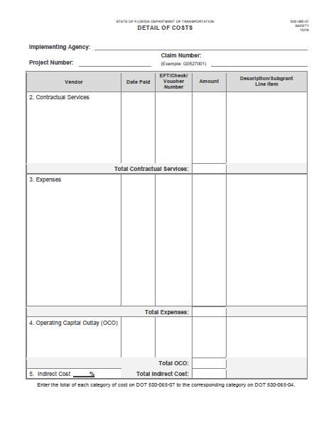

**Implementing Agency:** The name of the Implementing Agency on the Subgrant Agreement

**Project Number:** The project number indicated on the executed subgrant agreement.

**Claim Number:** The FDOT contract number following a sequential numbering beginning with 001. (Example: Contract number APH30; claim 1 would be APH30001 and claim 15 would be APH30015)

**Vendor:** The name of the vendor items were purchased from.

**Date Paid:** Check Date or transaction date

**EFT/Check/Voucher Number:** Check number, EFT number, or transaction number

**Amount:** Dollar amount being requested for reimbursement.

**Description/Subgrant Line Item:** Description of purchase and the line item identified in the subgrant agreement budget (Example: Item purchased was brochures and your subgrant line item was Printing, the description would read “brochures/Printing”)

Items should be listed under the category they funded under in the subgrant agreement budget table. (Example: The brochures were approved under the Printing line item under Expenses; therefore, the reimbursement is requested under the Expenses category)

**Indirect Costs:** Indirect cost is reimbursed based on the rate approved in the subgrant agreement. This rate is applied to all direct costs and calculated for each individual claim. If your subgrant budget does not include indirect costs, you may not request indirect costs. Please round up on 3rd digit for indirect calculations.

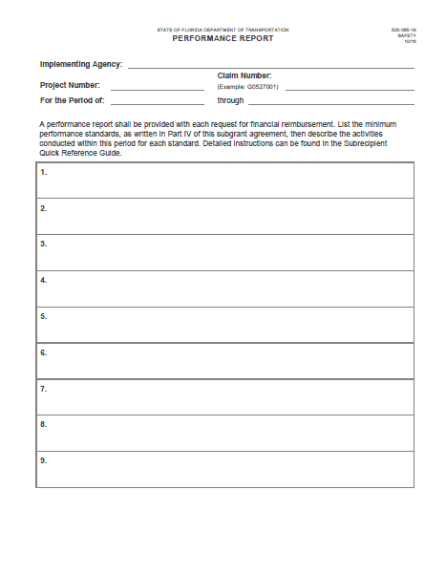**Implementing Agency:** The name of the Implementing Agency on the Subgrant Agreement

**Project Number:** The project number indicated on the executed subgrant agreement.

**Claim Number:** The FDOT contract number following a sequential numbering beginning with 001. (Example: Contract number APH30; claim 1 would be APH30001 and claim 15 would be APH30015)

**For the Period of:** The start date and end date must match the billing period being used by the subrecipient on the Statement of Highway Safety Project Costs form (500-065-04).

A performance report shall be provided with each request for financial reimbursement.

The minimum performance standards for your subgrant can be found in Part IV of the subgrant agreement. They should be repeated in that same order for performance reporting.

The minimum performance standards are high level umbrellas used to capture activity towards subgrant objectives. Objectives are identified in Part II of the subgrant agreement. All activities conducted under the subgrant support the objectives; therefore, objective activity can be reported under one of the minimum performance standards.

If you are unsure which objectives should be reported under which performance standard, please contact your respective Traffic Safety Program Manager.

**The following are examples of how to report objective activities under the minimum performance standards:**

**Example Objective:** Monitor and analyze crash related fatality and serious injury data for adults aged 65 and older.

**Example Performance Standard Report:**

1. **Provide assistance and support for the Aging Road User Program.**

An annual comparison report was created and distributed, to the data subcommittee of the coalition, on October 16th to advise the current status of crash related and serious injury data for adults aged 65 and above. This report was created in support of the subgrant objective to monitor and analyze crash related fatality and serious injury data for adults aged 65 and above.

**Example Objective:** Conduct at least one motorcycle safety education class per month.

**Example Performance Standard Report:**

1. **Conduct training operations for motorcycle safety.**

One motorcycle education training class was conducted at the local Harley Davidson dealership on October 15th. Attached is the roster of those citizens in attendance. This training supports the subgrant objective to conduct at least one motorcycle safety education class per month

**Example Objective:** Conduct at least 12 DUI saturation patrols within the subgrant cycle.

**Example Performance Standard Report:**

1. **Conduct enforcement operations for the enforcement of DUI in City of XYZ.**

One DUI saturation patrol was conducted on October 11th from 11pm to 3am. Three officers worked this detail (overtime activity report attached). This patrol supports the subgrant objective to conduct at least 12 DUI saturation patrols within the grant cycle.

**Example Objective:** Reduce speed related crashes by 5% from the previous year.

**Example Performance Standard Report:**

1. **Conduct Enforcement Operations for the reduction of Speed in ABC County**

Two overtime saturation patrols were conducted during this period. The first was October 4th from 11pm until 3am on Old Mill Street, where speed related fatalities and injuries are currently the most concentrated. Three officers worked this detail (overtime activity report attached). The second operation was October 31st from 7pm until 1am on the opposite entrance to Downtown ABC to mitigate speeding while children and families participating in Halloween activities. Two pedestrians were hit during this period last year; however, there were no injuries this year. Four officers worked this detail (overtime activity report attached). These activities are toward the subgrant objective to reduce speed related crashes and serious injuries 5% from the previous year

**Example Objective:** Conduct at least 4 coalition meetings within the subgrant period.

**Example Performance Standard Report:**

1. **Facilitate meetings for Florida Impaired Driving Coalition.**

Calendar invites, agendas and previous meeting minutes were forwarded to coalition members on October 31st in preparation for the December 8th coalition meeting (copies attached). The meeting room was confirmed and travel forms were provided for those members requiring travel reimbursement to attend the meeting. These activities are in support of the subgrant objective to conduct at least 4 coalition meetings within the subgrant cycle.

**Example Performance Standard Report:**

1. **Provide performance reports.**

Per the terms of the subgrant agreement, the performance report is provided with reimbursement claim number 1 for the period of October 1st through October 31st and all subgrant performance has been noted.

**Example Performance Standard Report:**

1. **Submit request(s) for financial reimbursement.**

Per the terms of the subgrant agreement, the financial reimbursement request is hereby submitted and includes all costs paid for this period.

|  |  |  |  |
| --- | --- | --- | --- |
| **Expense** | **Receipt Requirement**  **(Per Occurrence)** | **Reimbursement Guidelines** | **Justification Required** |
| Taxi Fares/Tips | Required  In excess of $25 | Taxi tips up to 15% of fare | No |
| Tolls | Required  In excess of $25 |  | No |
| Parking/Tips | Required  In excess of $25 | Long term parking should always be used  Mandatory valet parking tips up to $1 per occasion | Valet, short term and metered parking requires justification |
| Communication (Telephone/Fax/Internet) | If available | Charges must be for business purposes only | Yes |
| Portage | Not Required | $1.00 per bag for up to 5 bags per occurrence | More than 2 bags require justification |
| OtherTips/Gratuities | Not Required | Airport shuttle up to $1 per trip | No |

EXAMPLE:

