Q&A for . . . July 30, 2014

CADD Manager's Series (Part 3 of 3) – Printing
Q: Where can I find the power point for this webinar series?
A: All webinars recorded for downloading from the ECSO website.

Q: Are you talking about Microsoft or Bentley drivers?
A: Bentley Print Configuration files (.pltcfg). Windows print drivers will be discussed later in the presentation.

Q: Not to get off subject, but changing the weights, etc. is that against FDOT standards?
A: Paper is hardware dependent so if your printer is printing light you may find it necessary to make them heavier. The objective it to have legible printed output that can be copied multiple times (copy of a copy).

Q: I am using fdotprinter.pltcgf, but I can't set to find the scale of the fence?
A: You will need to use a Postscript driver for the scale to be set automatically. It is not possible using the system drivers.

Q: Have you talked about pset creation through Sheet Navigator, Sheet Index in this series?
A: That is covered towards the end of todays webinar.

Q: Is there a hierarchy of where styles are defined and which takes precedent?
A: All print styles contained in DGNLIB files which are defined in the MS_DGNLIBLIST variable will be available.

Q: Sorry to ask this question, are we using FDOT SS3 version?
A: It functions the same way in FDOT2010, FDOTSS2, and FDOTSS3. The webinar is showing FDOTSS3 which will be released later this year.

Q: Is there a way to set the order of how print styles display in the print styles dialog? It defaults to the naming.
A: They are listed in the order they are defined in the MS_DGNLIBLIST and then alphabetically within that file.

Q: How does the border comment work under the levels tab?
A: Border comments can be assigned in the print driver however FDOT uses text substitutions in the pen tables and turns off the border comments because most people did not like the extra line you get around the outside when using border comments.

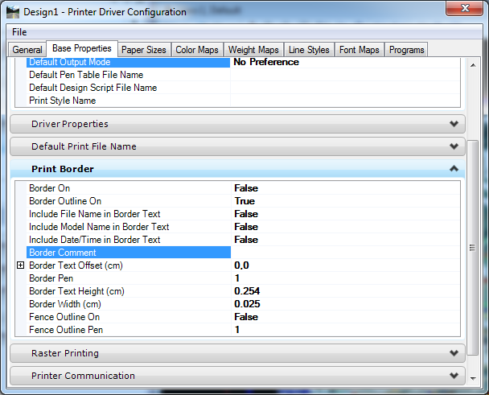

Q: Can it use Logicals to find the border?
A: Yes.

Q: Why are the print styles red?
A: It's a list of available print styles but you cannot modify them.

Q: Where is that file on the server that controls the Print Oder in Sheet Navigator?
A: It is the SheetInfo.pset file located in the mdlapps directory on the server.

Q: Will this be posted on the web?

A: Yes... Check the ECSO website in a day or two under Posted Webinars.

